Bangladesh University of Engineering and Technology
Department of Electrical and Electronic Engineering

EEE 306 (July 2023)
Power System I Laboratory
Final Project Report
Section: C2 Group: 04

Simulink based Program for Power System Dynamic Analysis

Course Instructors:
Shoilie Chakma, Lecturer
Kazi Ishrak Ahmed, Part-Time Lecturer

Signature of Instructor: ___________________________________________________

Academic Honesty Statement:
IMPORTANT! Please carefully read and sign the Academic Honesty Statement, below. Type the student ID and name, and put your signature. You will not receive credit for this project experiment unless this statement is signed in the presence of your lab instructor.

Signature: ____________________________  Full Name: Md. Sakif Imam  Student ID: 2006173 | Signature: ____________________________  Full Name: Orjun Kumar Paul  Student ID: 2006186
Signature: ____________________________  Full Name: Jain Uddin Ahmad  Student ID: 2006187 | Signature: ____________________________  Full Name: Nafis Ahmed  Student ID: 2006192
Signature: ____________________________
Full Name: AM Mostain Ahamed Sayami
Student ID: 2006193

Table of Contents
1 Abstract 1
2 Introduction 1
3 Design 2
3.1 Problem Formulation 2
3.1.1 Identification of Scope 2
3.1.2 Formulation of Problem 3
3.1.3 Analysis 5
3.2 Design Method 6
3.3 Circuit Diagram 8
3.4 Simulation Model 9
3.5 Full Source Code 11
4 Implementation 36
4.1 Description 36
4.2 Experiment and Data Collection 38
4.3 Data Analysis 38
4.4 Results 42
4.5 Simulink data collection and result analysis…………………………………………………47
4.6 load flow analysis…………………………………………………………………………….54
4.7 Github Link……………………………………………………………………………………54
5 Design Analysis and Evaluation 55
5.1 Novelty 55
5.2 Design Considerations 55
5.2.1 Considerations to public health and safety 55
5.2.2 Considerations to environment 56
5.2.3 Considerations to cultural and societal needs 56
5.3 Investigations 56
5.3.1 Literature Review 56
5.3.2 Experiment Design 56
5.3.3 Data Analysis and Interpretation 57
5.4 Limitations of Tools 57
5.5 Impact Assessment 57
5.5.1 Assessment of Societal and Cultural Issues 57
5.5.2 Assessment of Health and Safety Issues 57
5.5.3 Assessment of Legal Issues 57
5.6 Sustainability and Environmental Impact Evaluation 58
5.7 Ethical Issues 58
6 Reflection on Individual and Team work 59
6.1 Individual Contribution of Each Member 59
6.2 Mode of TeamWork 59
6.3 Diversity Statement of Team 59
6.4 Log Book of Project Implementation 60
7 Communication 61
7.1 Executive Summary 61
7.2 User Manual 61
8 Project Management and Cost Analysis 61
9 Future Work 62
10 References 63

1 Abstract

This project report encapsulates a comprehensive analysis of the IEEE 9 bus system, a cornerstone in power system dynamics and stability studies. Utilizing the robust simulation capabilities of Simulink coupled with the analytical prowess of MATLAB, this report delves into the intricate dynamics of power systems under various fault conditions. The Simulink model performs load flow analysis and simulates the operation of overcurrent relays during Line-to-Ground (LG), Line-to-Line (LL), Line-to-Line-to-Ground (LLG), and Three-Phase (LLLG) faults, providing graphical representations of current phases in the generator and transmission sides. In concert, the MATLAB code solves the dynamic equations for synchronous generators, excitation systems, and turbine systems, offering insights into the transient and steady-state responses of frequency, voltage magnitude, voltage angle, and generator currents. This dual-faceted approach not only enhances the understanding of power system behavior but also contributes to the development of resilient and efficient power networks, paving the way for the integration of renewable energy sources into the grid. The project underscores the significance of advanced simulation tools in addressing the challenges of modern power systems and in ensuring their reliable and efficient operation.

2 Introduction

The modern power system is a complex network of generation, transmission, and distribution systems that must operate reliably and efficiently under various conditions. The IEEE 9 bus system, a standard benchmark in power system analysis, serves as an essential model for studying and testing power system dynamic behavior and control strategies. This project report presents a comprehensive Simulink-based program for dynamic analysis of the IEEE 9 bus system, aptly named “Simulink-based programs for Power System dynamic analysis.”

The project focuses on the IEEE 9 bus system, a benchmark system widely used for power system analysis. The IEEE 9 bus system is simulated in Simulink to conduct load flow analysis and examine the behavior of the system under various fault conditions. Specifically, the project investigates the performance of overcurrent relay protection systems during fault scenarios such as line-to-ground (LG), line-to-line (LL), double line-to-ground (LLG), and triple line-to-ground (LLLG) faults.

In addition to Simulink simulations, the project incorporates MATLAB programming to solve the dynamic equations governing synchronous generators, excitation systems, and turbine systems. By varying system parameters and introducing disturbances at specific buses within the IEEE 9 bus system, the MATLAB code analyzes the transient response of key variables including frequency, voltage magnitude, voltage angle, and generator currents (d-axis and q-axis).

The primary objectives of this project are to:

Utilize Simulink for load flow analysis and fault analysis in the IEEE 9 bus system.
Investigate the performance of overcurrent relay protection systems under different fault scenarios.
Employ MATLAB programming to model and analyze the dynamic response of synchronous generators and associated systems during disturbances.
Analyze the transient behavior of critical variables before, during, and after disturbances in the power system.

By achieving these objectives, this project aims to contribute to the understanding of power system dynamics and enhance the capability to analyze and mitigate disturbances in modern power systems. The insights gained from this study are expected to be valuable for power system engineers, researchers, and practitioners involved in power system operation, control, and protection.

3 Design

3.1 Problem formulation

3.1.1 Identification of Scope

The scope of this project encompasses a detailed analysis of the IEEE 9 bus system using Simulink simulations and MATLAB modeling. Key areas of focus within this scope include load flow analysis, fault scenario investigations, and the examination of protective device behavior, particularly overcurrent relays. Additionally, the project aims to develop mathematical models for essential system components such as synchronous generators, excitation systems, and turbine systems. By integrating Simulink and MATLAB, this project provides a comprehensive exploration of power system dynamics under various operating conditions, offering insights into system performance and the effectiveness of protective measures.

3.1.2 Formulation of Problem

The main problem addressed in this project is to understand the dynamic behavior of the IEEE 9 bus system under different operating conditions, including normal operation, fault scenarios, and the presence of protective devices such as overcurrent relays. Specifically, the project aims to investigate how the system responds to faults of varying types (LG, LL, LLLG, LLG) and assess the impact of these faults on system variables such as frequency, voltage magnitude, voltage angle, and generator currents. Furthermore, the project seeks to analyze the performance of overcurrent relays in detecting and mitigating fault-induced disturbances. Another aspect of the problem is to develop mathematical models for key system components and use these models to simulate the system's transient behavior during and after fault occurrences.

MATLAB Code based Power System Modeling (Time-domain Simulation):

Synchronous Generator
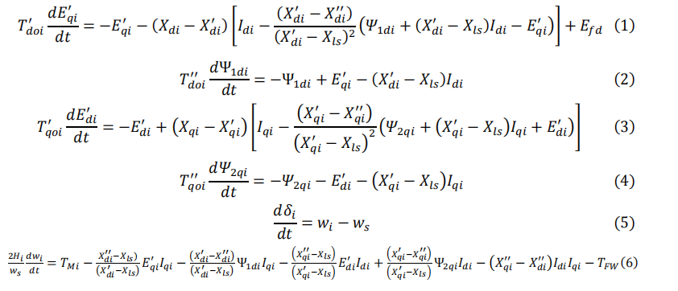
Excitation System
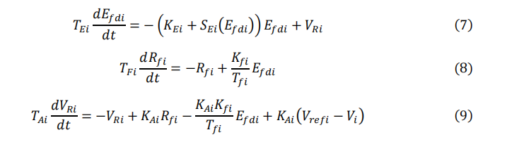
Turbine System
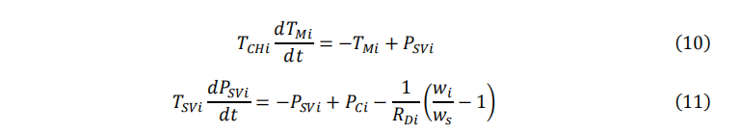

Algebraic Equations
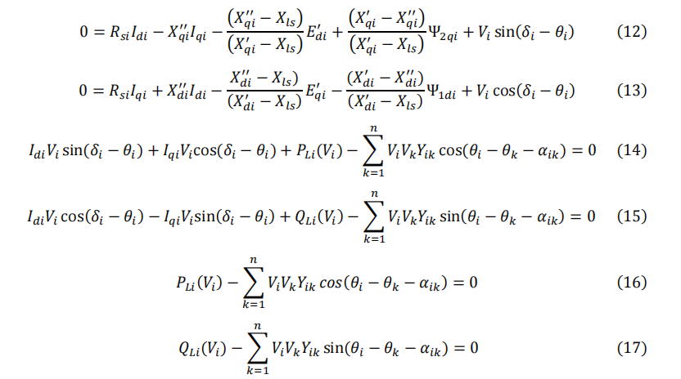
Load Model
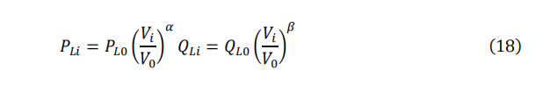
Reference Angle
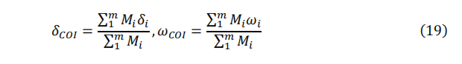
Initial Values Calculation
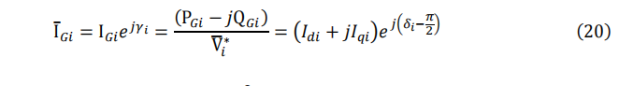

3.1.3 Analysis

The other part of PSDAT– that is, MATLAB programs– can be used to solve the
DAEs using either implicit or explicit methods. In the implicit method, all the DAEs are put in one file and called by the solver. The result is the time domain data for the states and algebraic variables. However, this method can be used for one type of disturbance: a step-change in the inputs (voltage reference or the mechanical input). For the network disturbance, which is more common, such as load change, line outage or a three-phase fault, the built-in solver does not allow the user to change these parameters once the solver is initiated, and hence the simulation stops at the time of disturbance. To resolve this limitation in the implicit approach, one of the following approaches can be followed. We can separate the DAEs into two sets of equations: DEs and AEs. The AEs are put as a nested function inside the main function used for solving the DEs. The AEs are solved using one of the MATLAB’s solvers whereas the DEs are solved using one of the ode solvers, specifically (ode15s) (ode23t) or All variables and parameters inside the nested function are visible in the main function. Another way to solve this limitation is to separate the solution into three different parts: pre-fault, during-fault, and post-fault. This method will be used in large–scale power systems.

The analysis in this project involves both Simulink simulations and MATLAB-based modeling to study the dynamic behavior of the IEEE 9 bus system. Through Simulink simulations, load flow analysis is performed to determine the steady-state operating conditions of the system under normal operation. Subsequently, fault scenarios are introduced, including LG, LL, LLLG, and LLG faults, to analyze the system's response under different fault conditions. The Simulink simulations also include the examination of overcurrent relay behavior to assess its effectiveness in protecting the system against faults.

In parallel, MATLAB-based modeling is employed to develop mathematical models for synchronous generators, excitation systems, and turbine systems within the IEEE 9 bus system. These models incorporate dynamic equations governing the behavior of these components and allow for the simulation of the system's transient response during fault occurrences. The analysis in MATLAB involves solving these dynamic equations to calculate system variables such as frequency, voltage magnitude, voltage angle, and generator currents at various time intervals before, during, and after fault disturbances.

Overall, the analysis in this project provides a comprehensive understanding of the IEEE 9 bus system's dynamic behavior under different operating conditions, enabling insights into system performance and the effectiveness of protective measures in ensuring stable and reliable power transmission.

3.2 Design Method

The design method for this power system project is described below:

In MATLAB code, we use implicit method to solve all modeling differential algebraic equations. We use ode15s MATLAB build in function to solve the differential equation.

In Simulink
Simulation Setup:
In the Simulink model, we use IEEE 9 bus system. So, we use three generators, three loads, three transformers, and six transmission lines.

Description of various components are described below:

Generators:
The generators are three phase generators. There is one swing bus and two PV buses. So, for two generators we have defined how much power they will generate and for the swing bus we defined the voltage level in PU as almost one. The generated voltage levels are 18 KV, 13.8 KV and 16.5 KV. The base voltages are kept at the same level as generated voltages.

Transformers:
There are three transformers. Each is right next to the generator. The transformers are step up transformers which are converting the generating voltages to the transmission level voltage which is 230 KV. The transformers are Wye-Delta connected.

Transmission lines:
There are a total of six transmission lines. For Simulink model, we use distributed parameters line which is basically long transmission line model. The length of each transmission line is 350 KM.

Three phases parallel RLC load:
The active power it absorbs is 90 MW and the reactive power it takes is 30 MVAR.

The three-phase circuit breaker:
It breaks all the three phases or basically cuts the generator from the transmission line.

Three phase faults:
Implements a fault (short-circuit) between any phase and the ground. When the external switching time mode is selected, a Simulink logical signal is used to control the fault operation.

We also use various measurement components.

Fault Modeling:
In the Simulink model, we introduce fault by using a component called three phase faults. Using this component, we can introduce 4 types of faults (e.g., LG, LL, LLLG, LLG). In our model, we faulted the bus near the generator side.

Implementation of Protective Devices:
We implemented an overcurrent relay system to protect the system from malfunction. The overcurrent relay controls the three-phase circuit breaker component which essentially cuts the phases of current from the generator where fault occurs.

3.3 Circuit Diagram

The IEEE 9 bus system single line diagram:

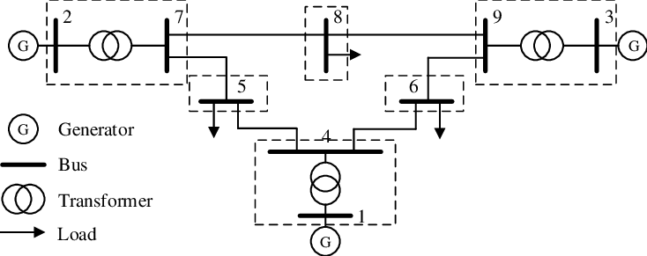

Here, we can see that in this system we have 9 buses across the power system. The loads are connected to bus number 5, 6 and 8. These are PQ buses. Generators are connected to bus number 1,2 and 3. Generator number 1 is swing and generators 2 and 3 are PV. Each generator is connected to step up transformers. The transformers are between bus number 1 and 4, 2 and 7, 3 and 9.

3.4 Simulation model

The Simulink model for simulation:

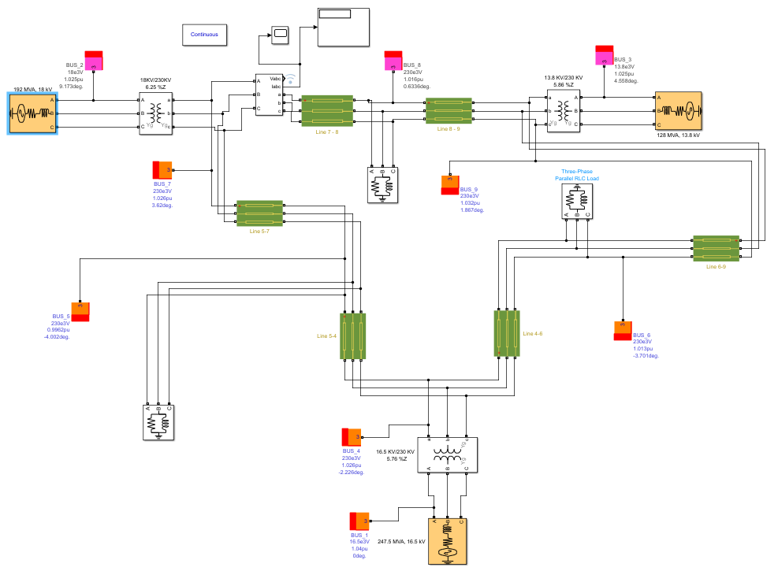

The Over current relay model
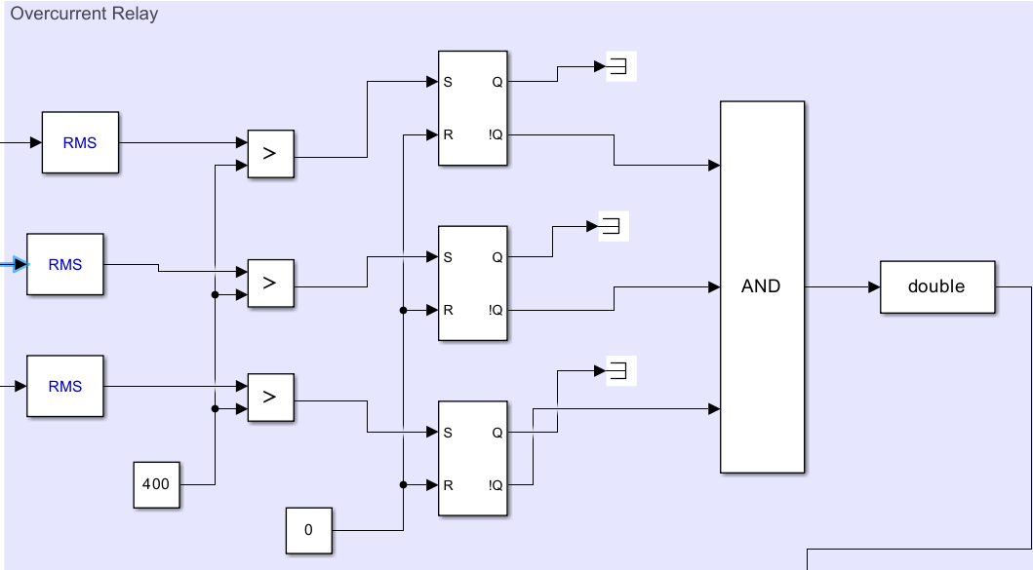

Explanation of working of Overcurrent relay model:

Here, we can see RMS components which measure the true root mean square (RMS) value of the input signal at the specified fundamental frequency. Here input signal is three phase current value.

Then, the next component that is used here is relational operator which compares the RMS value to the predetermined fault current value. If the rms value surpasses the value of tolerance value or fault current value, then the output is one otherwise zero.

After that the next component is SR Flip flop. It is set up in a way that if the current exceeds the fault current then it would change its hold state and it eventually triggers the circuit breaker.

The fault creating system and the circuit breaker model

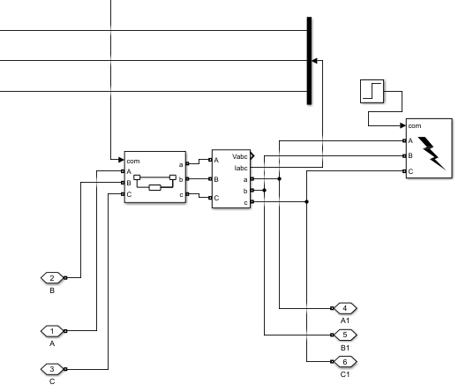

3.5 Full Source Code

Before running this code, we must ensure all requirement toolbox of MATLAB installed. We used math-power software to solve Ybus matrix. So Math-power application must be installed .

Main code:
% Clear the command window, workspace, and close all figures
clc;
clear all;
close all;
% Start the timer
tic
%% Variables of System Modeling (Time-domain Simulation)
% Define global variables
global Vref ws PC Yabs Yang m n PL QL a0 x0 V0 alpha beta H Xd Xdp Xdpp Xq Xqp Xqpp Td0p Td0pp Tq0p Tq0pp Rs Xls Dm KA TA KE TE KF TF Ax Bx TCH TSV RD MH bb1 bb2 aa1 aa2 x01 x02 x03 f
% Define the number of generators (m) and buses (n)
m = 3;
n = 9;
% Define the base power (in MVA) for per unit conversion
baseMVA = 100;
% Define the synchronous speed (in rad/sec)
ws = 2*pi*50;
% Create a vector of synchronous speeds for each generator
ws_vector = ws*ones(1,m);
% Initialize the speed of each generator to the synchronous speed
w0=ws_vector;
% Set options for the power flow solver
mpopt = mpoption('PF_ALG', 1,'ENFORCE_Q_LIMS',0);
% Run the power flow solver on the IEEE 9-bus system
[RESULTS1, SUCCESS] =runpf('IEEE9Bus',mpopt);
% Load the IEEE 9-bus system data
mpc=IEEE9Bus;
% Extract the bus, branch, and generator data from the power flow results
bus1=RESULTS1.bus;
branch1=RESULTS1.branch;
gen1=RESULTS1.gen;
% Compute the bus admittance matrix
Ybus1 = makeYbus(baseMVA, bus1, branch1);
Ybus1=full(Ybus1);
% Assign the bus admittance matrix to Ybus and Y
Ybus=Ybus1;
Y = Ybus;
% Assign the bus, branch, and generator data
bus=bus1;
branch=branch1;
gen=gen1;
% Compute the magnitude and angle of the bus admittance matrix
Yabs = abs(Y);
Yang = angle(Y);
% Extract the voltage magnitude and angle from the bus data
IC1 = bus(:,8);
IC2 = bus(:,9);
% Extract the real power output of each generator from the generator data
gen0 = zeros(n,1);
gen0(1:m) = gen(1:m,2);
genP = gen0;
IC3 = genP;
% Convert the real power output to per unit
IC3 = IC3/baseMVA;
% Extract the reactive power output of each generator from the generator data
gen0 = zeros(n,1);
gen0(1:m) = gen(1:m,3);
genQ = gen0;
genQ = genQ+bus(:,6);
IC4 = genQ;
% Convert the reactive power output to per unit
IC4 = IC4/baseMVA;
% Extract the real and reactive power loads from the bus data
IC5 = bus(:,3);
IC5 = IC5/baseMVA;
IC6 = bus(:,4);
IC6 = IC6/baseMVA;
% Combine the voltage magnitude and angle, real and reactive power output, and real and reactive power load into a single matrix
IC = [ IC1 IC2 IC3 IC4 IC5 IC6];
% Assign the real and reactive power loads
PL = IC(:,5);
QL = IC(:,6);
% Assign the real and reactive power output
PG = IC(:,3);
QG = IC(:,4);
% Convert the voltage angle to radians and transpose the vector
TH0 = IC(:,2)*pi/180;
TH0 = TH0';
% Assign the voltage magnitude and transpose the vector
V0 = IC(:,1);
V0 = V0';
% Assign the voltage magnitude and angle of each generator
VG0 = V0(1:m);
THG0 = TH0(1:m);
%% Dynamic Parameters
% Define the machine data
MD=[
23.640 6.4000 3.0100; % 1 - H
0.1460 0.8958 1.3125; % 2 - Xd
0.0608 0.1198 0.1813; % 3 - Xdp
0.0489 0.0881 0.1133; % 4 - Xdpp
0.0969 0.8645 1.2578; % 5 - Xq
0.0969 0.1969 0.2500; % 6 - Xqp
0.0396 0.0887 0.0833; % 7 - Xqpp
8.9600 6.0000 5.8900; % 8 - Tdop
0.1150 0.0337 0.0420; % 9 - Td0pp
0.3100 0.5350 0.6000; % 10- Tqop
0.0330 0.0780 0.1875; % 11- Tq0pp
0.0041 0.0026 0.0035; % 12- RS
0.1200 0.1020 0.0750; % 13- Xls
0.1*(2*23.64)/ws 0.2*(2*6.4)/ws 0.3*(2*3.01)/ws % 14- Dm
];
% Define the excitation data
ED=[
20.000 *ones(1,m); % 1- KA
0.2000 *ones(1,m); % 2- TA
1.0000 *ones(1,m); % 3- KE
0.3140 *ones(1,m); % 4- TE
0.0630 *ones(1,m); % 5- KF
0.3500 *ones(1,m); % 6- TF
0.0039 *ones(1,m); % 7- Ax
1.5550 *ones(1,m); % 8- Bx
];
% Define the turbine data
TD=[
0.10 *ones(1,m); % 1- TCH
0.05 *ones(1,m); % 2- TSV
0.05 *ones(1,m); % 3- RD
];
% Assign the machine data
H = MD(1,:);
Xd = MD(2,:);
Xdp = MD(3,:);
Xdpp = MD(4,:);
Xq = MD(5,:);
Xqp = MD(6,:);
Xqpp = MD(7,:);
Td0p = MD(8,:);
Td0pp = MD(9,:);
Tq0p = MD(10,:);
Tq0pp = MD(11,:);
Rs = MD(12,:);
Xls = MD(13,:);
Dm = MD(14,:);
% Assign the excitation data
KA = ED(1,:);
TA = ED(2,:);
KE = ED(3,:);
TE = ED(4,:);
KF = ED(5,:);
TF = ED(6,:);
Ax = ED(7,:);
Bx = ED(8,:);
% Assign the turbine data
TCH = TD(1,:);
TSV = TD(2,:);
RD = TD(3,:);
% Compute the inertia constant
MH=2*H./ws;
%% Initial Values Calculation (State Variables)
% Calculate the initial voltage phasor for each generator
Vphasor = VG0.*exp(1i*(THG0));
% Calculate the initial current phasor for each generator
Iphasor = conj((PG(1:m)'+1i*QG(1:m)')./Vphasor);
% Calculate the initial internal voltage for each generator
E0 = Vphasor+(Rs+1i*Xq).*Iphasor;
% Calculate the magnitude of the internal voltage for each generator
Em = abs(E0);
% Calculate the angle of the internal voltage for each generator
D0 = angle(E0);
% Calculate the initial d-axis current for each generator
Id0 = real(Iphasor.*exp(-1i*(D0-pi/2)));
% Calculate the initial q-axis current for each generator
Iq0 = imag(Iphasor.*exp(-1i*(D0-pi/2)));
% Calculate the initial d-axis transient emf for each generator
Edp0 = (Xq-Xqp).*Iq0;
% Calculate the initial q-axis stator current component for each generator
Si2q0 = (Xls-Xq).*Iq0;
% Calculate the initial q-axis transient emf for each generator
Eqp0 = Rs.*Iq0+Xdp.*Id0+V0(1:m).*cos(D0-TH0(1:m));
% Calculate the initial d-axis stator current component for each generator
Si1d0 = Eqp0-(Xdp-Xls).*Id0;
% Calculate the initial field voltage for each generator
Efd0 = Eqp0+(Xd-Xdp).*Id0;
% Calculate the initial mechanical torque for each generator
TM0 = ((Xdpp-Xls)./(Xdp-Xls)).*Eqp0.*Iq0+((Xdp-Xdpp)./(Xdp-Xls)).*Si1d0.*Iq0+((Xqpp-Xls)./(Xqp-Xls)).*Edp0.*Id0-((Xqp-Xqpp)./(Xqp-Xls)).*Si2q0.*Id0+(Xqpp-Xdpp).*Id0.*Iq0;
% Calculate the initial voltage regulator output for each generator
VR0 = (KE+Ax.*exp(Bx.*Efd0)).*Efd0;
% Calculate the initial exciter field voltage for each generator
RF0 = (KF./TF).*Efd0;
% Calculate the initial reference voltage for each generator
Vref = V0(1:m)+VR0./KA;
% Calculate the initial power system stabilizer output for each generator
PSV0 = TM0;
% Assign the initial power system stabilizer output to PC
PC = PSV0;
% Assign the initial values to the state variables
x0(1:m) = Eqp0;
x0(m+1:2*m) = Si1d0;
x0(2*m+1:3*m) = Edp0;
x0(3*m+1:4*m) = Si2q0;
x0(4*m+1:5*m) = D0;
x0(5*m+1:6*m) = ws_vector;
x0(6*m+1:7*m) = Efd0;
x0(7*m+1:8*m) = RF0;
x0(8*m+1:9*m) = VR0;
x0(9*m+1:10*m) = TM0;
x0(10*m+1:11*m) = PSV0;
% Assign the initial values to x011
x011=x0;
% Assign the initial values to a0
a0 = [Id0 Iq0 V0 TH0];
% Assign the initial values to x01
x01=[x011 a0];
%% Solving Equation
% Create matrix grid to eliminate for-loops (generator buses)
[bb1, aa1] = ndgrid(1:m, 1:n);
% Create matrix grid to eliminate for-loops (load buses)
[bb2, aa2] = ndgrid(m+1:n, 1:n);
% Create the mass matrix
M1 = ones(1,11*m);
M2 = zeros(1,2*(m+n));
MT = [M1 M2];
M0 = diag(MT);
%% fault or any disturbance
% Define the fault bus
f=8;
% Define the fault resistance and reactance
alpha=2;
beta=1;
% Define the fault start and end times
tf1=1;
tf2=1.1;
% Define the step size, simulation time, and options for the first time period
st1 =1e-1;
tsim1 = 1;
tspan1 = [0 , tsim1];
opt = odeset('Mass',M0,'MaxStep',st1);
% Solve the differential-algebraic equations for the first time period
[t1, x1]=ode15s(@DAEs1,tspan1,x01,opt);
% Update the state variables at the end of the first time period
x02=x1(end,:);
x02(13*m+f)=1e-3;
% Define the step size, simulation time, and options for the second time period
st2 =1e-4;
tsim2 = tf2-tf1 ;
tspan2 = [0 , tsim2];
opt = odeset('Mass',M0,'MaxStep',st2);
% Solve the differential-algebraic equations for the second time period
[t2, x2]=ode15s(@DAEs2,tspan2,x02,opt);
% Update the state variables at the end of the second time period
x03=[x2(end,1:11*m) x1(end,11*m+1:end)];
% Define the step size, simulation time, and options for the third time period
st3 =1e-2;
tsim3 = 10-tf2 ;
tspan3 = [0 , tsim3];
opt = odeset('Mass',M0,'MaxStep',st3);
% Solve the differential-algebraic equations for the third time period
[t3, x3]=ode15s(@DAEs3,tspan3,x03,opt);
% Combine the state variables and time vectors for all time periods
x=[x1; x2; x3;];
t=[t1; t2 + tf1; t3 + tf2;];
% Stop the timer
toc
%% Plotting
% Assign the state variables for plotting
Eqp = x(:,1:m);
Si1d = x(:,m+1:2*m);
Edp = x(:,2*m+1:3*m);
Si2q = x(:,3*m+1:4*m);
Delta = x(:,4*m+1:5*m);
w = x(:,5*m+1:6*m);
Efd = x(:,6*m+1:7*m);
RF = x(:,7*m+1:8*m);
VR = x(:,8*m+1:9*m);
TM = x(:,9*m+1:10*m);
PSV = x(:,10*m+1:11*m);
Id = x(:,11*m+1:12*m);
Iq = x(:,12*m+1:13*m);
V = x(:,13*m+1:13*m+n);
TH = x(:,13*m+n+1:13*m+2*n);
% Figure 2: Plot of Generator Id (pu) vs Time
figure(2); % Create a new figure window with the figure number 2
plot(t,Id, 'linewidth',2); % Plot the variable 'Id' against 't' with a line width of 2
grid on; % Turn the grid on for better visualization of data points
set(gca,'fontsize',16); % Set the font size of the current axes to 16
legend({'G1','G2','G3'}, 'FontSize',12); % Add a legend to the plot with the specified labels and font size
xlabel('Time (sec.)','FontSize',16,'FontWeight','bold'); % Label the x-axis
ylabel('Generator Id (pu)','FontSize',16,'FontWeight','bold'); % Label the y-axis
% Figure 3: Plot of Generator Iq (pu) vs Time
figure(3); % Create a new figure window with the figure number 3
plot(t,Iq, 'linewidth',2); % Plot the variable 'Iq' against 't' with a line width of 2
grid on; % Turn the grid on for better visualization of data points
set(gca,'fontsize',16); % Set the font size of the current axes to 16
legend({'G1','G2','G3'}, 'FontSize',12); % Add a legend to the plot with the specified labels and font size
xlabel('Time (sec.)','FontSize',16,'FontWeight','bold'); % Label the x-axis
ylabel('Generator Iq (pu)','FontSize',16,'FontWeight','bold'); % Label the y-axis
% Figure 4: Plot of Voltage angle (degree) vs Time
figure(4); % Create a new figure window with the figure number 4
plot(t,TH, 'linewidth',2); % Plot the variable 'TH' against 't' with a line width of 2
grid on; % Turn the grid on for better visualization of data points
set(gca,'fontsize',16); % Set the font size of the current axes to 16
legend({'Bus 1','Bus 2','Bus 3','Bus 4','Bus 5','Bus 6','Bus 7','Bus 8','Bus 9'}, 'FontSize',12); % Add a legend to the plot with the specified labels and font size
xlabel('Time (sec.)','FontSize',16,'FontWeight','bold'); % Label the x-axis
ylabel(' Voltage angle (degree)','FontSize',16,'FontWeight','bold'); % Label the y-axis
% Figure 5: Plot of Voltage magnitude (pu) vs Time
figure(5); % Create a new figure window with the figure number 5
plot(t,V, 'linewidth',2); % Plot the variable 'V' against 't' with a line width of 2
grid on; % Turn the grid on for better visualization of data points
set(gca,'fontsize',16); % Set the font size of the current axes to 16
legend({'Bus 1','Bus 2','Bus 3','Bus 4','Bus 5','Bus 6','Bus 7','Bus 8','Bus 9'}, 'FontSize',12); % Add a legend to the plot with the specified labels and font size
xlabel('Time (sec.)','FontSize',16,'FontWeight','bold'); % Label the x-axis
ylabel(' Voltage magnitude (pu)','FontSize',16,'FontWeight','bold'); % Label the y-axis
% Figure 6: Plot of Rotor angle (degree) vs Time
figure(6); % Create a new figure window with the figure number 6
plot(t,Delta*180/pi, 'linewidth',2); % Plot the variable 'Delta' (converted from radians to degrees) against 't' with a line width of 2
grid on; % Turn the grid on for better visualization of data points
set(gca,'fontsize',16); % Set the font size of the current axes to 16
legend({'G1','G2','G3'}, 'FontSize',12); % Add a legend to the plot with the specified labels and font size
xlabel('Time (sec.)','FontSize',16,'FontWeight','bold'); % Label the x-axis
ylabel(' Rotor angle (degree)','FontSize',16,'FontWeight','bold'); % Label the y-axis
% Figure 7: Plot of Frequency (Hz.) vs Time
figure(7); % Create a new figure window with the figure number 7
plot(t,w/2/pi, 'linewidth',2); % Plot the variable 'w' (converted from rad/sec to Hz) against 't' with a line width of 2
grid on; % Turn the grid on for better visualization of data points
set(gca,'fontsize',16); % Set the font size of the current axes to 16
legend({'G1','G2','G3'}, 'FontSize',12); % Add a legend to the plot with the specified labels and font size
xlabel('Time (sec.)','FontSize',16,'FontWeight','bold'); % Label the x-axis
ylabel(' Frequency (Hz.)','FontSize',16,'FontWeight','bold'); % Label the y-axis
%END

Bus data function:

Bus data function :
% This function defines the IEEE 9 bus system
function mpc = IEEE9Bus
% mpc is a structure that will contain the system data
mpc.baseMVA = 100; % baseMVA sets the power base for the system in MVA
%% Bus data
% Each row corresponds to a bus in the system
% Columns are as follows:
% bus_i: Bus number (1-9)
% type: Bus type (1 = PQ, 2 = PV, 3 = reference)
% Pd: Active power demand (MW)
% Qd: Reactive power demand (MVAr)
% Gs: Shunt conductance (MW at V = 1.0 p.u.)
% Bs: Shunt susceptance (MVAr at V = 1.0 p.u.)
% area: Area number
% Vm: Voltage magnitude (p.u.)
% Va: Voltage angle (degrees)
% baseKV: Base voltage (kV)
% zone: Zone number
% Vmax: Maximum voltage magnitude (p.u.)
% Vmin: Minimum voltage magnitude (p.u.)
mpc.bus = [
1 3 0 0 0 0 1 1.04 0 345 1 1.1 0.9;
2 2 0 0 0 0 1 1.025 0 345 1 1.1 0.9;
3 2 0 0 0 0 1 1.025 0 345 1 1.1 0.9;
4 1 0 0 0 0 1 1 0 345 1 1.1 0.9;
5 1 125 50 0 0 1 1 0 345 1 1.1 0.9;
6 1 90 30 0 0 1 1 0 345 1 1.1 0.9;
7 1 0 0 0 0 1 1 0 345 1 1.1 0.9;
8 1 100 35 0 0 1 1 0 345 1 1.1 0.9;
9 1 0 0 0 0 1 1 0 345 1 1.1 0.9;
];
%% Generator data
% Each row corresponds to a generator in the system
% Columns are as follows:
% bus: Bus number
% Pg: Active power output (MW)
% Qg: Reactive power output (MVAr)
% Qmax: Maximum reactive power output (MVAr)
% Qmin: Minimum reactive power output (MVAr)
% Vg: Voltage magnitude setpoint (p.u.)
% mBase: Total MVA base of machine, defaults to baseMVA
% status: Machine status, > 0 - machine in service, <= 0 - machine out of service
% Pmax: Maximum active power output (MW)
% Pmin: Minimum active power output (MW)
mpc.gen = [
1 0 0 300 -300 1.040 100 1 250 10 0 0 0 0 0 0 0 0 0 0 0;
2 163 0 300 -300 1.025 100 1 300 10 0 0 0 0 0 0 0 0 0 0 0;
3 85 0 300 -300 1.025 100 1 270 10 0 0 0 0 0 0 0 0 0 0 0;
];
%% Branch data
% Each row corresponds to a branch (transmission line) in the system
% Columns are as follows:
% fbus: "From" bus number
% tbus: "To" bus number
% r: Resistance (p.u.)
% x: Reactance (p.u.)
% b: Susceptance (p.u.)
% rateA: Long-term (steady-state) rating, MVA
% rateB: Short-term (emergency) rating, MVA
% rateC: Short-time (10 minute) rating, MVA
% ratio: Transformer off nominal turns ratio (= 0 for lines)
% angle: Transformer phase shift angle (degrees), positive => delay
% status: Branch status, > 0 - in service, <= 0 - out of service
% angmin: Minimum angle difference, angle[fbus] - angle[tbus] (degrees)
% angmax: Maximum angle difference, angle[fbus] - angle[tbus] (degrees)
mpc.branch = [
1 4 0 0.0576 0 250 250 250 0 0 1 -360 360;
4 6 0.017 0.092 0.158 250 250 250 0 0 1 -360 360;
6 9 0.039 0.17 0.358 150 150 150 0 0 1 -360 360;
3 9 0 0.0586 0 300 300 300 0 0 1 -360 360;
8 9 0.0119 0.1008 0.209 150 150 150 0 0 1 -360 360;
7 8 0.0085 0.072 0.149 250 250 250 0 0 1 -360 360;
2 7 0 0.0625 0 250 250 250 0 0 1 -360 360;
5 7 0.032 0.161 0.306 250 250 250 0 0 1 -360 360;
4 5 0.01 0.085 0.176 250 250 250 0 0 1 -360 360;
];
end

Solving DAE function:

DAEs function 1:

% This function defines the Differential Algebraic Equations (DAEs) for a power system
function out = DAEs1(~,x)
% The global variables are parameters of the system
global Vref ws PC Ax Bx Yabs Yang Dm PL QL m n H Xd Xdp Xdpp Xq Xqp Xqpp Td0p Td0pp Tq0p Tq0pp Rs Xls KA TA KE TE KF TF TCH TSV RD MH V0 alpha beta bb1 bb2 aa1 aa2
%% Defining the states and variables
% The state variables are defined from the input vector x
% Eqp, Si1d, Edp, Si2q are the generator fluxes
% Delta is the generator rotor angle
% w is the generator speed
% Efd is the field voltage
% RF is the field winding flux
% VR is the regulator output
% TM is the mechanical torque
% PSV is the power system stabilizer output
% Id, Iq are the d and q axis currents
% V is the bus voltage
% TH is the bus voltage angle
% COI is the center of inertia speed, used as the reference speed
Eqp=x(1:1*m);
Si1d=x(1*m+1:2*m);
Edp=x(2*m+1:3*m);
Si2q=x(3*m+1:4*m);
Delta=x(4*m+1:5*m);
w=x(5*m+1:6*m);
Efd=x(6*m+1:7*m);
RF=x(7*m+1:8*m);
VR=x(8*m+1:9*m);
TM=x(9*m+1:10*m);
PSV=x(10*m+1:11*m);
Id=x(11*m+1:12*m);
Iq=x(12*m+1:13*m);
V=x(13*m+1:13*m+n);
TH=x(13*m+n+1:13*m+2*n);
COI=sum(w.*MH')/sum(MH); % Reference
Vref0=Vref; PC0=PC;
%% DAEs
VG=V(1:m);
PL2=PL'.*((V'./V0).^alpha); % Voltage dependant active loads
QL2=QL'.*((V'./V0).^beta); % Voltage dependant reactive loads
% PL2=PL'; QL2=QL'; %PL2(f)=0; QL2(f)=0;
S1=(1./Td0p).*(-Eqp'-(Xd-Xdp).*(Id'-((Xdp-Xdpp)./(Xdp-Xls).^2).*(Si1d'+(Xdp-Xls).*Id'-Eqp'))+Efd');
S2=(1./Td0pp).*(-Si1d'+Eqp'-(Xdp-Xls).*Id');
S3=(1./Tq0p).*(-Edp'+(Xq-Xqp).*(Iq'-((Xqp-Xqpp)./(Xqp-Xls).^2).*(Si2q'+(Xqp-Xls).*Iq'+Edp')));
S4=(1./Tq0pp).*(-Si2q'-Edp'-(Xqp-Xls).*Iq');
S5=w'-COI;
S6=(ws./(2*H)).*(TM'-((Xdpp-Xls)./(Xdp-Xls)).*Eqp'.*Iq'-((Xdp-Xdpp)./(Xdp-Xls)).*Si1d'.*Iq'-((Xqpp-Xls)./(Xqp-Xls)).*Edp'.*Id'+((Xqp-Xqpp)./(Xqp-Xls)).*Si2q'.*Id'-(Xqpp-Xdpp).*Id'.*Iq'-Dm.*(w'-ws));
S7=(1./TE).*((-(KE+Ax.*exp(Bx.*Efd'))).*Efd'+VR');
S8=(1./TF).*(-RF'+(KF./TF).*Efd');
S9=(1./TA).*(-VR'+KA.*RF'-((KA.*KF)./TF).*Efd'+KA.*(Vref0-VG'));
S10=(1./TCH).*(-TM'+PSV');
S11=(1./TSV).*(-PSV'+PC0-(1./RD).*(w'./ws-1));
%% Generator stator and power flow eq's
Vectorized_angle1 = (TH(bb1)-TH(aa1)-Yang(1:m,1:n));
Vectorized_mag1 = V(1:m) .* V(1:n)' .* Yabs(1:m,1:n);
sum1 = sum(Vectorized_mag1 .* cos(Vectorized_angle1),2);
sum2 = sum(Vectorized_mag1 .* sin(Vectorized_angle1),2);
VG=V(1:m); THG=TH(1:m); Angle_diff=Delta-THG;
SE1=Rs.*Id'-Xqpp.*Iq'-((Xqpp-Xls)./(Xqp-Xls)).*Edp'+((Xqp-Xqpp)./(Xqp-Xls)).*Si2q'+VG'.*(sin(Angle_diff))';
SE2=Rs.*Iq'+Xdpp.*Id'-((Xdpp-Xls)./(Xdp-Xls)).*Eqp'-((Xdp-Xdpp)./(Xdp-Xls)).*Si1d'+VG'.*(cos(Angle_diff))';
PV1=(Id'.*VG'.*(sin(Angle_diff'))+Iq'.*VG'.*(cos(Angle_diff')))-PL2(1:m)-sum1';
PV2=(Id'.*VG'.*(cos(Angle_diff'))-Iq'.*VG'.*(sin(Angle_diff')))-QL2(1:m)-sum2';
%% Non-generator power flow eq's
Vectorized_angle2 = (TH(bb2)-TH(aa2)-Yang(m+1:n,1:n));
Vectorized_mag2 = V(m+1:n) .* V(1:n)' .* Yabs(m+1:n,1:n);
sum3 = sum(Vectorized_mag2 .* cos(Vectorized_angle2),2);
sum4 = sum(Vectorized_mag2 .* sin(Vectorized_angle2),2);
PQ1=-PL2(m+1:n)-sum3';
PQ2=-QL2(m+1:n)-sum4';
out=[S1'; S2'; S3'; S4'; S5'; S6'; S7'; S8'; S9'; S10'; S11'; SE1'; SE2'; PV1'; PQ1'; PV2'; PQ2'];
end

DAEs function 2:

% This function defines the Differential Algebraic Equations (DAEs) for a power system
function out = DAEs2(~,x)
% The global variables are parameters of the system
global Vref ws PC Ax Bx Yabs Yang Dm PL QL m n H Xd Xdp Xdpp Xq Xqp Xqpp Td0p Td0pp Tq0p Tq0pp Rs Xls KA TA KE TE KF TF TCH TSV RD MH V0 alpha beta bb1 bb2 aa1 aa2 f
% The state variables are defined from the input vector x
% Eqp, Si1d, Edp, Si2q are the generator fluxes
% Delta is the generator rotor angle
% w is the generator speed
% Efd is the field voltage
% RF is the field winding flux
% VR is the regulator output
% TM is the mechanical torque
% PSV is the power system stabilizer output
% Id, Iq are the d and q axis currents
% V is the bus voltage
% TH is the bus voltage angle
% COI is the center of inertia speed, used as the reference speed
Eqp=x(1:1*m);
Si1d=x(1*m+1:2*m);
Edp=x(2*m+1:3*m);
Si2q=x(3*m+1:4*m);
Delta=x(4*m+1:5*m);
w=x(5*m+1:6*m);
Efd=x(6*m+1:7*m);
RF=x(7*m+1:8*m);
VR=x(8*m+1:9*m);
TM=x(9*m+1:10*m);
PSV=x(10*m+1:11*m);
Id=x(11*m+1:12*m);
Iq=x(12*m+1:13*m);
V=x(13*m+1:13*m+n);
TH=x(13*m+n+1:13*m+2*n);
COI=sum(w.*MH')/sum(MH); % Reference
Vref0=Vref; PC0=PC;
V(f)=1e-5*V(f); %TH(f)=0.0001*TH(f);
VG=V(1:m);
PL2=PL'.*((V'./V0).^alpha); % Voltage dependant active loads
QL2=QL'.*((V'./V0).^beta); % Voltage dependant reactive loads
PL2(f)=0; QL2(f)=0;
S1=(1./Td0p).*(-Eqp'-(Xd-Xdp).*(Id'-((Xdp-Xdpp)./(Xdp-Xls).^2).*(Si1d'+(Xdp-Xls).*Id'-Eqp'))+Efd');
S2=(1./Td0pp).*(-Si1d'+Eqp'-(Xdp-Xls).*Id');
S3=(1./Tq0p).*(-Edp'+(Xq-Xqp).*(Iq'-((Xqp-Xqpp)./(Xqp-Xls).^2).*(Si2q'+(Xqp-Xls).*Iq'+Edp')));
S4=(1./Tq0pp).*(-Si2q'-Edp'-(Xqp-Xls).*Iq');
S5=w'-COI;
S6=(ws./(2*H)).*(TM'-((Xdpp-Xls)./(Xdp-Xls)).*Eqp'.*Iq'-((Xdp-Xdpp)./(Xdp-Xls)).*Si1d'.*Iq'-((Xqpp-Xls)./(Xqp-Xls)).*Edp'.*Id'+((Xqp-Xqpp)./(Xqp-Xls)).*Si2q'.*Id'-(Xqpp-Xdpp).*Id'.*Iq'-Dm.*(w'-ws));
S7=(1./TE).*((-(KE+Ax.*exp(Bx.*Efd'))).*Efd'+VR');
S8=(1./TF).*(-RF'+(KF./TF).*Efd');
S9=(1./TA).*(-VR'+KA.*RF'-((KA.*KF)./TF).*Efd'+KA.*(Vref0-VG'));
S10=(1./TCH).*(-TM'+PSV');
S11=(1./TSV).*(-PSV'+PC0-(1./RD).*(w'./ws-1));
%% Generator stator and power flow eq's
Vectorized_angle1 = (TH(bb1)-TH(aa1)-Yang(1:m,1:n));
Vectorized_mag1 = V(1:m) .* V(1:n)' .* Yabs(1:m,1:n);
sum1 = sum(Vectorized_mag1 .* cos(Vectorized_angle1),2);
sum2 = sum(Vectorized_mag1 .* sin(Vectorized_angle1),2);
VG=V(1:m); THG=TH(1:m); Angle_diff=Delta-THG;
SE1=Rs.*Id'-Xqpp.*Iq'-((Xqpp-Xls)./(Xqp-Xls)).*Edp'+((Xqp-Xqpp)./(Xqp-Xls)).*Si2q'+VG'.*(sin(Angle_diff))';
SE2=Rs.*Iq'+Xdpp.*Id'-((Xdpp-Xls)./(Xdp-Xls)).*Eqp'-((Xdp-Xdpp)./(Xdp-Xls)).*Si1d'+VG'.*(cos(Angle_diff))';
PV1=(Id'.*VG'.*(sin(Angle_diff'))+Iq'.*VG'.*(cos(Angle_diff')))-PL2(1:m)-sum1';
PV2=(Id'.*VG'.*(cos(Angle_diff'))-Iq'.*VG'.*(sin(Angle_diff')))-QL2(1:m)-sum2';
%% Non-generator power flow eq's
Vectorized_angle2 = (TH(bb2)-TH(aa2)-Yang(m+1:n,1:n));
Vectorized_mag2 = V(m+1:n) .* V(1:n)' .* Yabs(m+1:n,1:n);
sum3 = sum(Vectorized_mag2 .* cos(Vectorized_angle2),2);
sum4 = sum(Vectorized_mag2 .* sin(Vectorized_angle2),2);
PQ1=-PL2(m+1:n)-sum3';
PQ2=-QL2(m+1:n)-sum4';
%--------------------------------------------------------------
out=[S1'; S2'; S3'; S4'; S5'; S6'; S7'; S8'; S9'; S10'; S11'; SE1'; SE2'; PV1'; PQ1'; PV2'; PQ2'];
end

DAEs function 3:

% DAEs function 3:
% This function calculates the differential-algebraic equations (DAEs) for a power system model.
% The function takes in a vector of state variables 'x' and returns the derivatives of these state variables.
function out = DAEs3(~,x)
% Global variables are declared. These are parameters of the system and are accessible to all functions.
global Vref ws PC Ax Bx Yabs Yang Dm PL QL m n H Xd Xdp Xdpp Xq Xqp Xqpp Td0p Td0pp Tq0p Tq0pp Rs Xls KA TA KE TE KF TF TCH TSV RD MH V0 alpha beta bb1 bb2 aa1 aa2
% The state variables are extracted from the input vector 'x'.
Eqp=x(1:1*m); % Exciter internal voltage related to q-axis
Si1d=x(1*m+1:2*m); % Stator flux linkage related to d-axis
Edp=x(2*m+1:3*m); % Exciter internal voltage related to d-axis
Si2q=x(3*m+1:4*m); % Stator flux linkage related to q-axis
Delta=x(4*m+1:5*m); % Rotor angle
w=x(5*m+1:6*m); % Rotor speed
Efd=x(6*m+1:7*m); % Excitation voltage
RF=x(7*m+1:8*m); % Field winding voltage
VR=x(8*m+1:9*m); % Regulator output voltage
TM=x(9*m+1:10*m); % Mechanical torque
PSV=x(10*m+1:11*m); % Power system stabilizer output
Id=x(11*m+1:12*m); % d-axis current
Iq=x(12*m+1:13*m); % q-axis current
V=x(13*m+1:13*m+n); % Terminal voltage
TH=x(13*m+n+1:13*m+2*n); % Terminal voltage angle
% Calculations
COI=sum(w.*MH')/sum(MH); % Center of inertia frequency, used as reference frequency
% Initial conditions
Vref0=Vref; PC0=PC;
% Generator terminal voltage
VG=V(1:m);
% Voltage dependent active and reactive loads
PL2=PL'.*((V'./V0).^alpha);
QL2=QL'.*((V'./V0).^beta);
% State equations for the generator, exciter and stabilizer
S1=(1./Td0p).*(-Eqp'-(Xd-Xdp).*(Id'-((Xdp-Xdpp)./(Xdp-Xls).^2).*(Si1d'+(Xdp-Xls).*Id'-Eqp'))+Efd');
S2=(1./Td0pp).*(-Si1d'+Eqp'-(Xdp-Xls).*Id');
S3=(1./Tq0p).*(-Edp'+(Xq-Xqp).*(Iq'-((Xqp-Xqpp)./(Xqp-Xls).^2).*(Si2q'+(Xqp-Xls).*Iq'+Edp')));
S4=(1./Tq0pp).*(-Si2q'-Edp'-(Xqp-Xls).*Iq');
S5=w'-COI;
S6=(ws./(2*H)).*(TM'-((Xdpp-Xls)./(Xdp-Xls)).*Eqp'.*Iq'-((Xdp-Xdpp)./(Xdp-Xls)).*Si1d'.*Iq'-((Xqpp-Xls)./(Xqp-Xls)).*Edp'.*Id'+((Xqp-Xqpp)./(Xqp-Xls)).*Si2q'.*Id'-(Xqpp-Xdpp).*Id'.*Iq'-Dm.*(w'-ws));
S7=(1./TE).*((-(KE+Ax.*exp(Bx.*Efd'))).*Efd'+VR');
S8=(1./TF).*(-RF'+(KF./TF).*Efd');
S9=(1./TA).*(-VR'+KA.*RF'-((KA.*KF)./TF).*Efd'+KA.*(Vref0-VG'));
S10=(1./TCH).*(-TM'+PSV');
S11=(1./TSV).*(-PSV'+PC0-(1./RD).*(w'./ws-1));
% Calculation of power flow equations
Vectorized_angle1 = (TH(bb1)-TH(aa1)-Yang(1:m,1:n));
Vectorized_mag1 = V(1:m) .* V(1:n)' .* Yabs(1:m,1:n);
sum1 = sum(Vectorized_mag1 .* cos(Vectorized_angle1),2);
sum2 = sum(Vectorized_mag1 .* sin(Vectorized_angle1),2);
VG=V(1:m); THG=TH(1:m); Angle_diff=Delta-THG;
SE1=Rs.*Id'-Xqpp.*Iq'-((Xqpp-Xls)./(Xqp-Xls)).*Edp'+((Xqp-Xqpp)./(Xqp-Xls)).*Si2q'+VG'.*(sin(Angle_diff))';
SE2=Rs.*Iq'+Xdpp.*Id'-((Xdpp-Xls)./(Xdp-Xls)).*Eqp'-((Xdp-Xdpp)./(Xdp-Xls)).*Si1d'+VG'.*(cos(Angle_diff))';
PV1=(Id'.*VG'.*(sin(Angle_diff'))+Iq'.*VG'.*(cos(Angle_diff')))-PL2(1:m)-sum1';
PV2=(Id'.*VG'.*(cos(Angle_diff'))-Iq'.*VG'.*(sin(Angle_diff')))-QL2(1:m)-sum2';
% Calculation of power flow equations for load buses
Vectorized_angle2 = (TH(bb2)-TH(aa2)-Yang(m+1:n,1:n));
Vectorized_mag2 = V(m+1:n) .* V(1:n)' .* Yabs(m+1:n,1:n);
sum3 = sum(Vectorized_mag2 .* cos(Vectorized_angle2),2);
sum4 = sum(Vectorized_mag2 .* sin(Vectorized_angle2),2);
PQ1=-PL2(m+1:n)-sum3';
PQ2=-QL2(m+1:n)-sum4';
% The output is a vector of the derivatives of the state variables.
out=[S1'; S2'; S3'; S4'; S5'; S6'; S7'; S8'; S9'; S10'; S11'; SE1'; SE2'; PV1'; PQ1'; PV2'; PQ2'];
end

4 Implementation

4.1 Description

In the Simulink model, we use various components such as generators as three phase source, transmission lines, three phase transformers, three phase parallel RLC loads, three phase circuit breaker, three phase fault creating system, various measurement components etc. to model the IEEE 9 bus system.

Dynamic analysis of a power system involves studying the time-dependent behavior of the system, particularly it response to disturbances and changes. This type of analysis is crucial for understanding and ensuring the stability, reliability, and performance of power systems. Here are key aspects and methods involved in dynamic analysis.
Modeling:
Generator Models: Accurate representation of synchronous generators is essential. Models like the classical model (single machine infinite bus), two-axis transient stability model, and more advanced models may be used.
Transmission Line Models: The transmission lines' characteristics and parameters are considered in the dynamic models to simulate the wave propagation and interactions.
Load Models: Dynamic load models, representing the time-varying behavior of loads, are included for a more realistic simulation.
Differential Equations:The dynamic behavior of power systems is described by a set of nonlinear differential equations. These equations represent the mechanical, electrical, and control dynamics of generators, as well as the interactions with the network.
Transient Stability Analysis:This analysis assesses the system's ability to maintain synchronism following a disturbance. The simulation typically involves studying the rotor angle stability and angular velocity deviations after a disturbance.
Small Signal Stability Analysis:Analyzing the small-signal stability involves linearizing the system around an operating point to assess its response to small disturbances. This helps in understanding the system's behavior under small perturbations.
Voltage Stability Analysis:Voltage stability is crucial for maintaining a steady voltage profile in the power system. Dynamic analysis assesses the system's ability to withstand disturbances and maintain acceptable voltage levels.
Frequency Response Analysis:Analyzing the system's frequency response provides insights into how the system reacts to changes in generation or load. It helps in understanding the damping characteristics and potential oscillations
Control System Design:Dynamic analysis aids in designing and tuning control systems for various components of the power system, such as generators, excitation systems, and power system stabilizers.
Event Analysis:Simulating and analyzing specific events, such as faults or sudden changes in load or generation, helps understand the system's response to emergencies.
Time-Domain Simulation:Numerical simulation tools, such as the Runge-Kutta method, are commonly used for solving the differential equations governing the dynamic behavior of power systems.
Integration with EMS (Energy Management System): Dynamic analysis tools are often integrated into Energy Management Systems to provide real-time monitoring and control of the power system.
Dynamic analysis is crucial for power system engineers and operators to ensure the stability and reliability of the grid under various operating conditions and disturbances. Advanced simulation software and real-time monitoring tools play a significant role in conducting dynamic analyses of power systems.

4.2 Data Collection

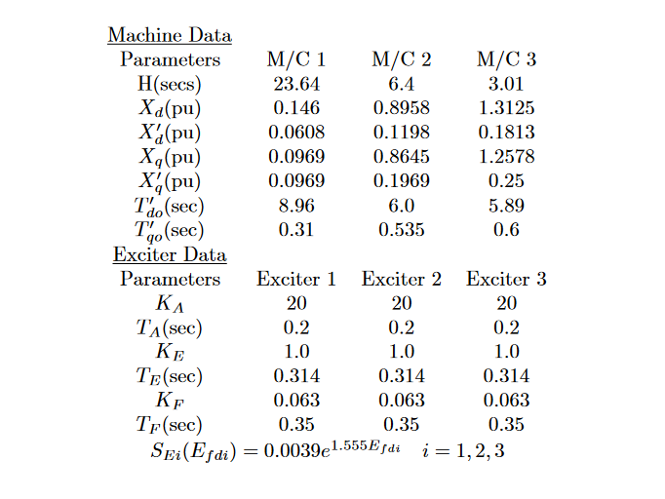

4.3 Data Analysis:

In order to model the IEEE 9 bus system, we have to govern differential equation. We need some initial value and constants to solve those equations.Here are discussed some of the characteristics equation of synchronous machine.
Synchronous Machine two axis circuit:

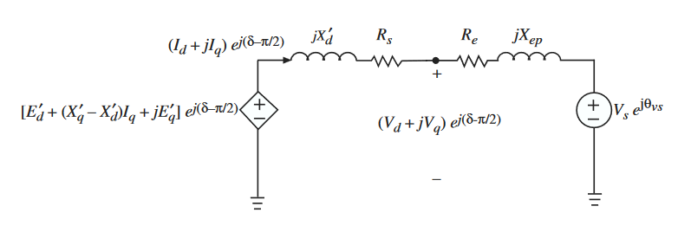

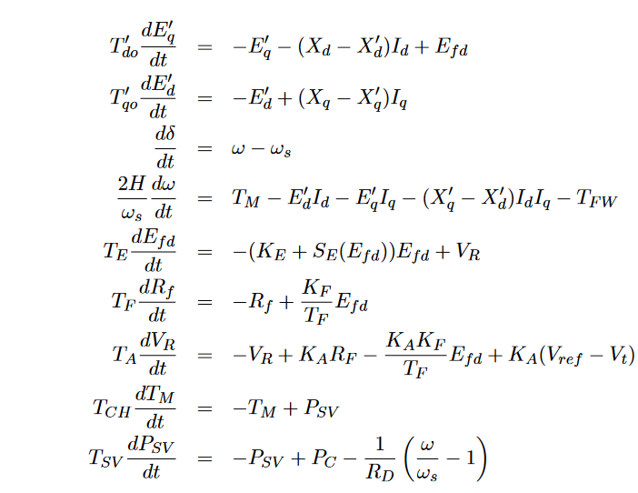
Synchronous machine saturation Model:

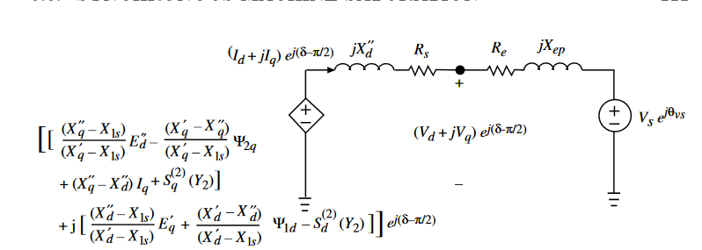

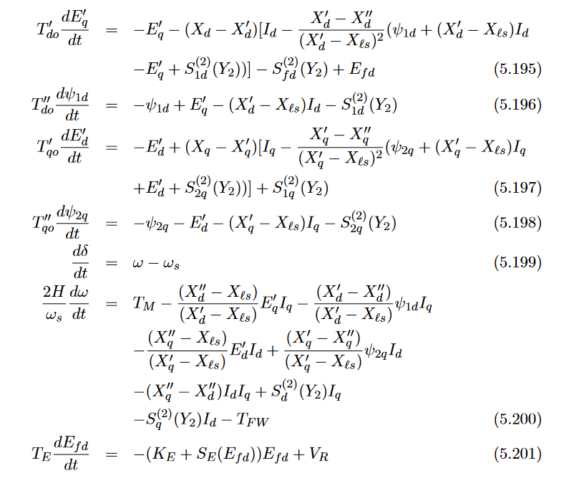

So, two axis models and saturation models can be combined and form a new differential equations.

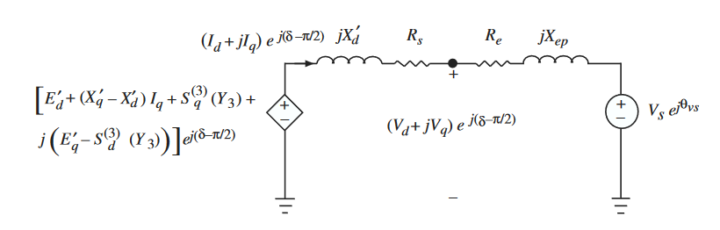
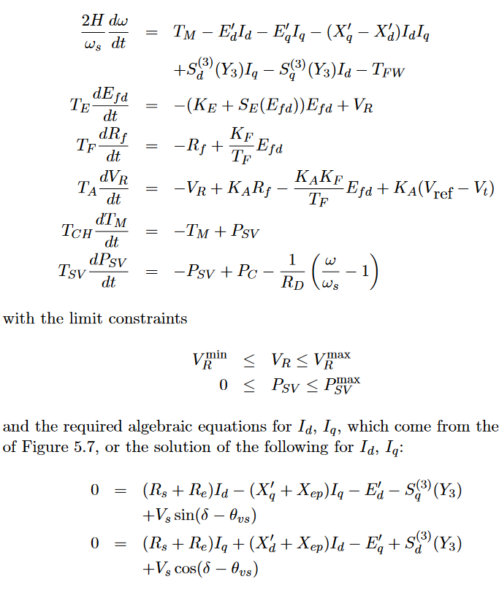

4.4 Results:

We have computed different dynamic parameters like rotor angle, voltage, magnitude, bus voltage angle, frequency by solving governing differential equations . We observed the change in network side due to fault in particular bus. We formed three governing differential equation for pre , during and post faults. We set the bus voltage zero for faulted bus during fault calculation.

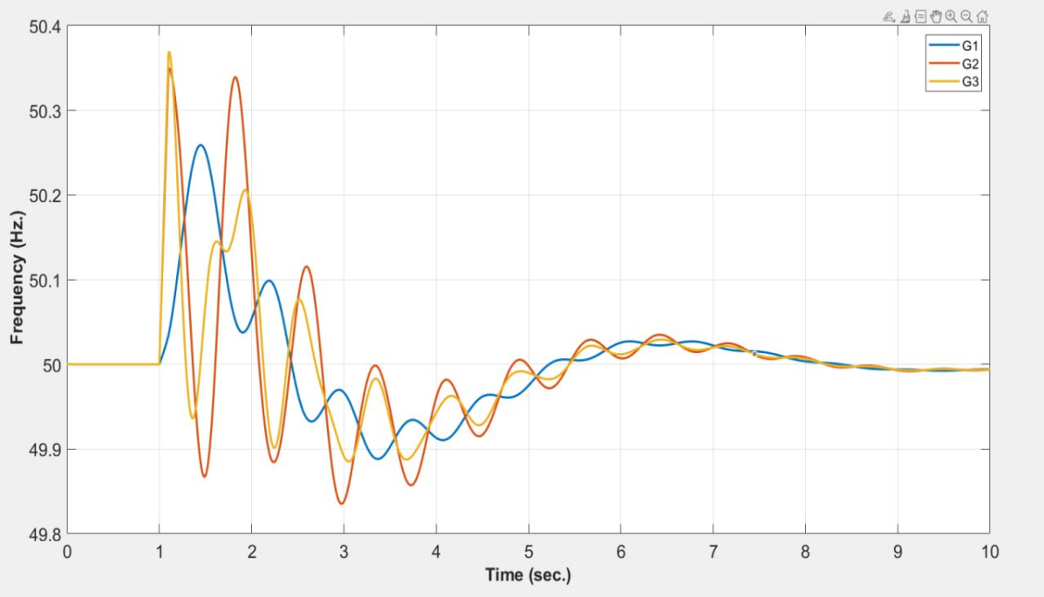

Fig: Frequency vs time plot

Here we see that frequency of generator is varied with respect to time. Fault occurred after 1s and almost after 7s frequency reach steady state again. In our country operating frequency of power system is 50Hz. And can be varied within 48.8Hz to 50.4Hz range. Anything different from that range can cause blackout.

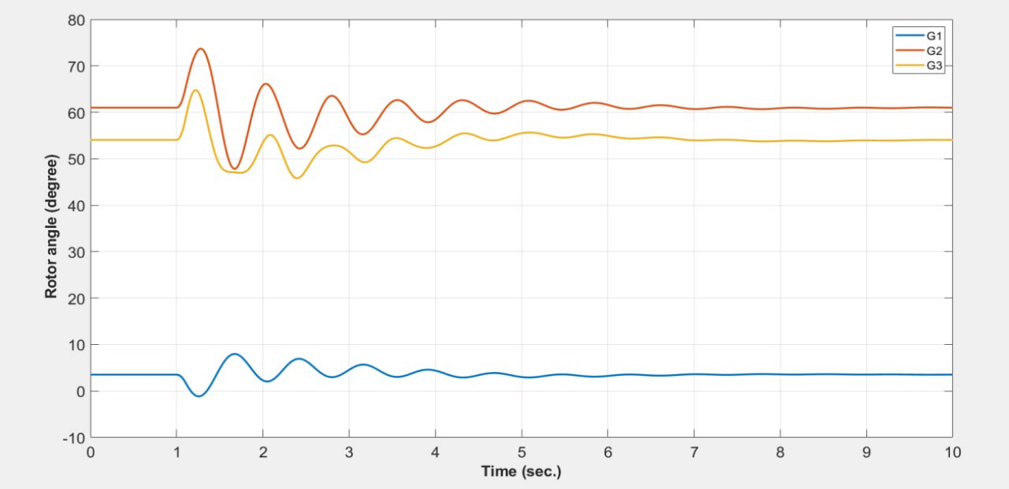
Fig: Rotor angle vs time plot

Here are three generators of which generator 1 is slack bus .So its magnitude is 1 and rotor angle is 0⁰.After 1s rotor angle deviates from 0⁰ .It follows the inverse trend of generator 2 and 3. When rotor angle of generator 2 and 3 go upward generator 1 go downward to compensate.

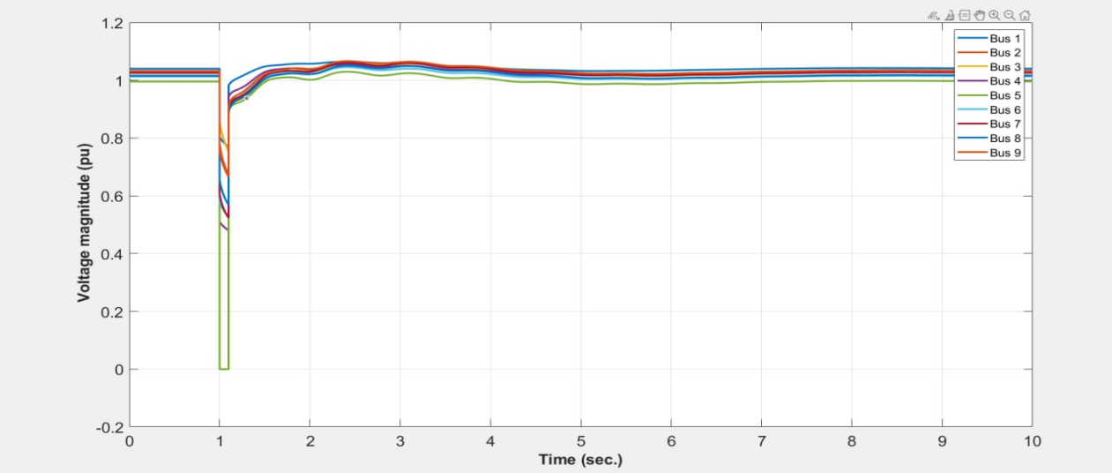
Fig:Voltage magnitude vs time plot

As fault occurred at bus 5 ,bus 5 voltage becomes zero abruptly. For this reason other bus voltage will also fall down. After a few seconds all bus voltage reach steady state again.

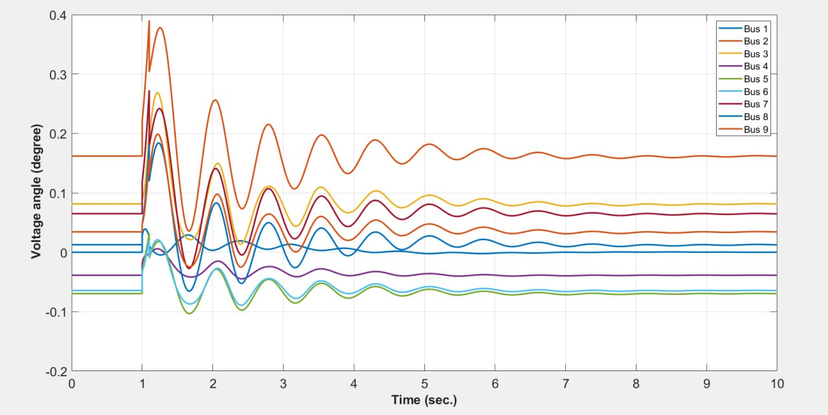

Fig:Voltage angle vs time plot

The voltage angle of faulted bus experience rapid and possibly large swings as the generators respond to the disturbance. Once the fault is cleared and the system stabilizes, the voltage angle at faulted bus will gradually return to a new steady-state value.

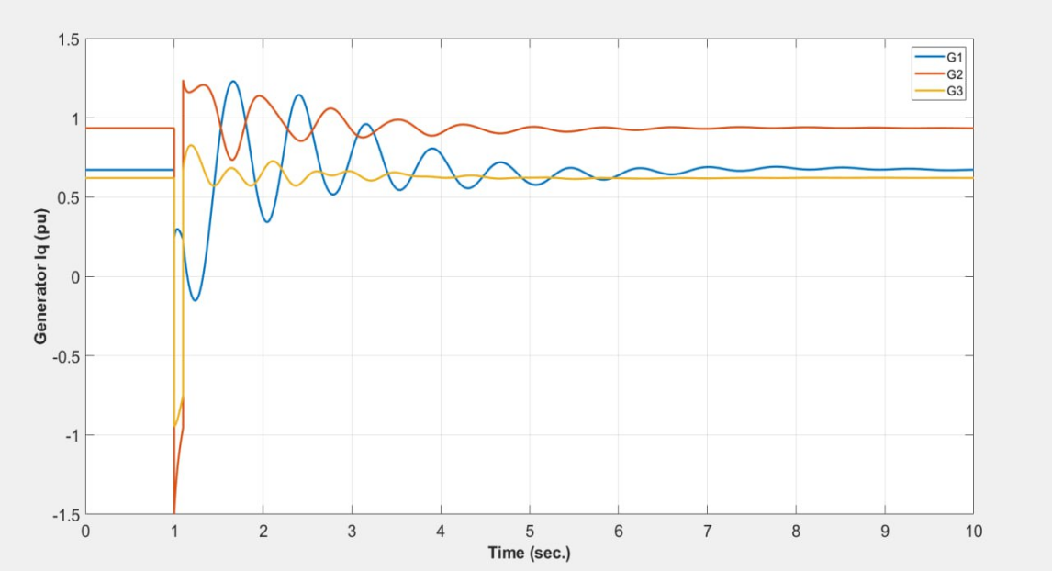
Fig:Generator Iq vs time plot

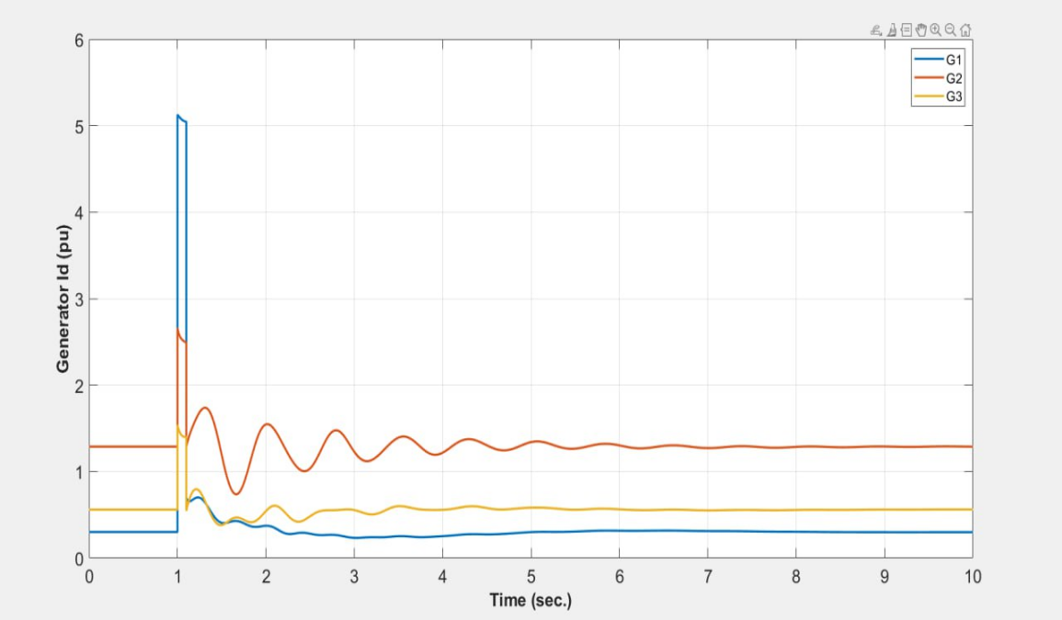
Fig:Generator Id vs time plot

Quadrature and direct axis currents of three generators change damped sinusoidally after the fault occurs.
The damped sinusoidal behavior observed in the response of the direct axis (d-axis) and quadrature axis (q-axis) currents during transient events in power systems is a result of the inherent damping and oscillatory characteristics of the system. This behavior is described by the transient response of the system following a disturbance, such as a fault or sudden change in operating conditions.

The equations for the d-axis (Id) and q-axis (Iq) currents in a synchronous machine's rotating reference frame, which are derived using Park's transformation, involve trigonometric functions. These functions introduce oscillatory behavior, while the inclusion of damping terms results in the decay of the oscillations over time.

The transient response can be expressed as a damped sinusoidal waveform:
Id(t)=Id(0)⋅e−(D/2H)t⋅cos(ωdt+ϕd)
Iq(t)=Iq(0)⋅e−(D/2H)t⋅cos(ωqt+ϕq)
The damping factor DD determines how quickly the transient response decays. A higher damping factor leads to faster decay, indicating a more stable system response. The oscillatory nature of the cosine terms in the equations reflects the periodic behavior of the currents during the transient period.

4.5 Simulink data collection and result analysis

We have created the faults in the generator side and observed the current of generators side and transmission side with using overcurrent relay or without using overcurrent relay.

LG fault without overcurrent relay (Generator side)

In this case, phase a current of the generator side has been faulted and that’s why in the phase a current is high.

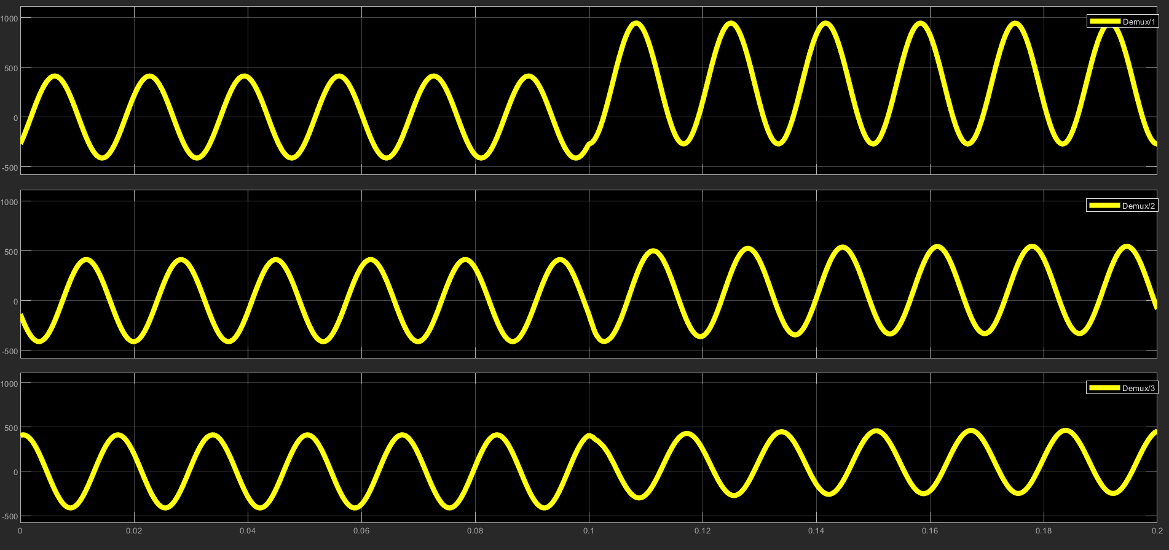

LG fault without overcurrent relay (Steady state current in (Transmission side))

Below is the current of phase a (yellow), phase b (Blue) and phase c (red) of the transmission side due to the LG fault. We generally assume that the fault phase will have high current flowing and the current of other two phases will be zero. But we can see that phase b and phase c are not zero probably because we are not cutting off the generator in this case. We let the fault current flow with very high magnitude.

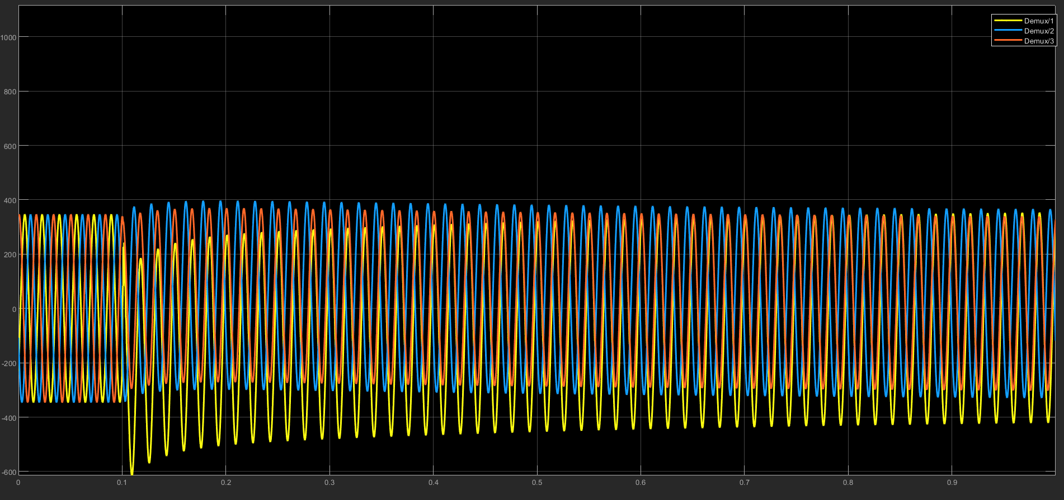

LG fault with overcurrent relay (Generator side)

Here, we can see that at 0.1 second LG fault happened. Because we are using the overcurrent relay in this case, the moment the current of phase a of generator side exceeds the predefined 600 Amp current and triggers the over relay circuit which enacts the three-phase fault circuit breaker.

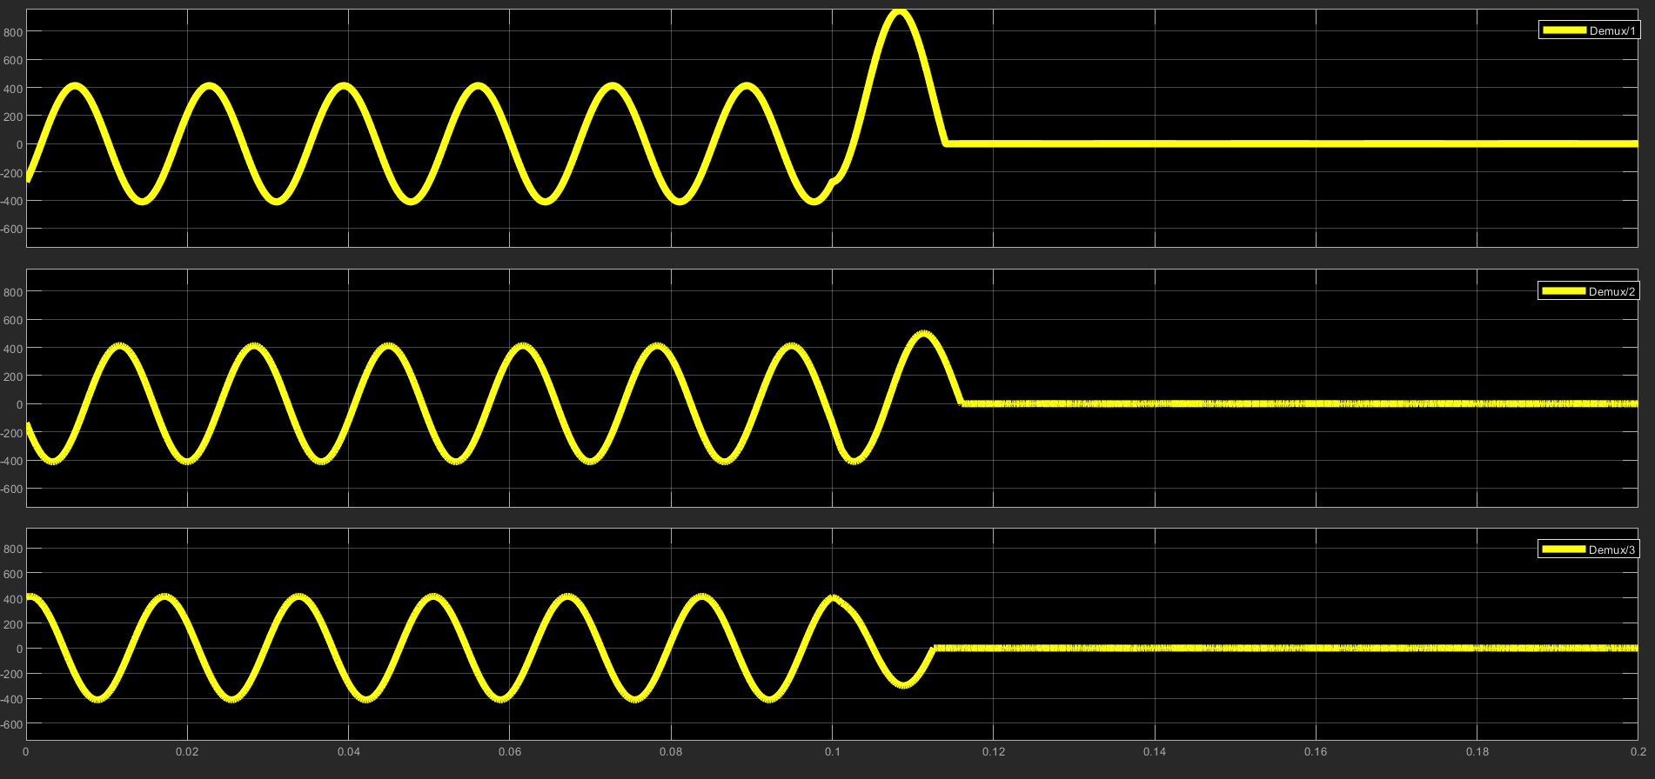

LG fault with overcurrent relay (Steady state current in transmission side)
In this case we can see that phase b and phase c current is very low compared to fault phase a current.

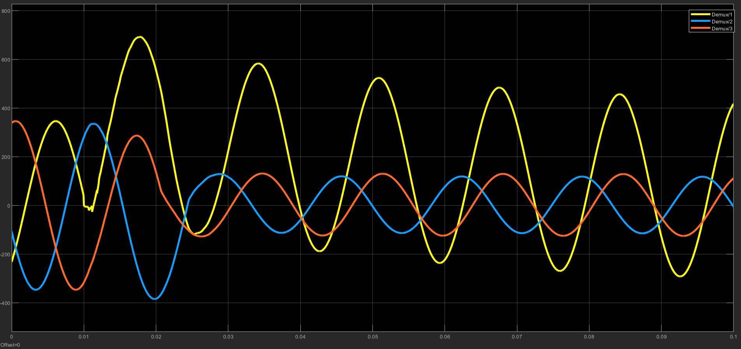

LL fault with Overcurrent Relay (generator side)

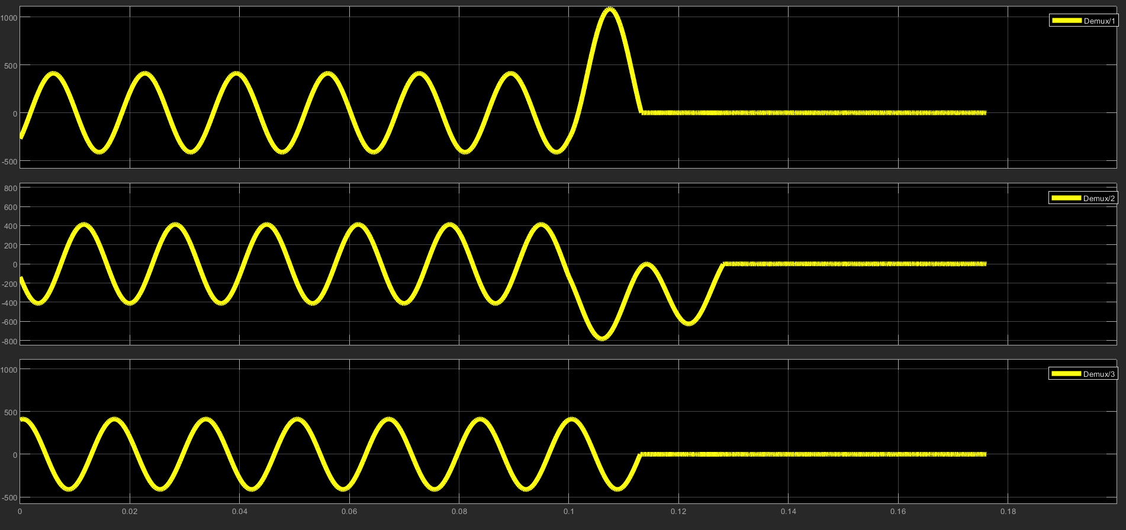
LL fault with Overcurrent Relay (Transmission side)

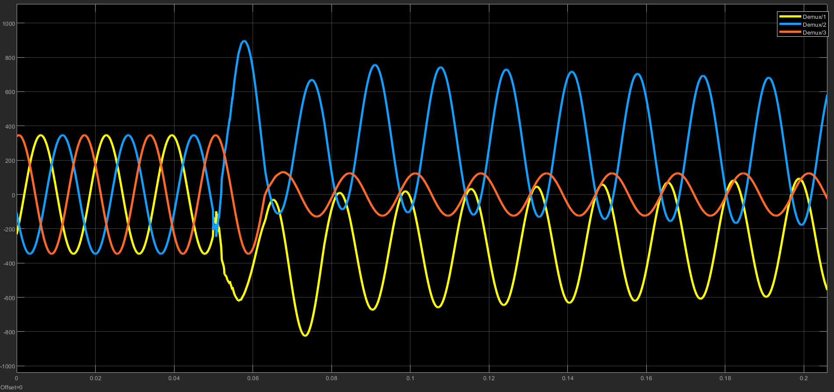

LL fault without Overcurrent Relay (Generator side)

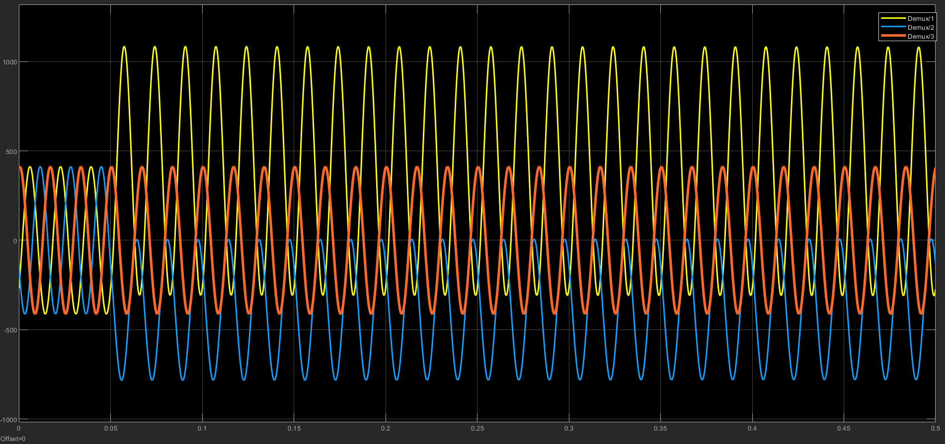

LL fault without Overcurrent Relay(Transmission side)

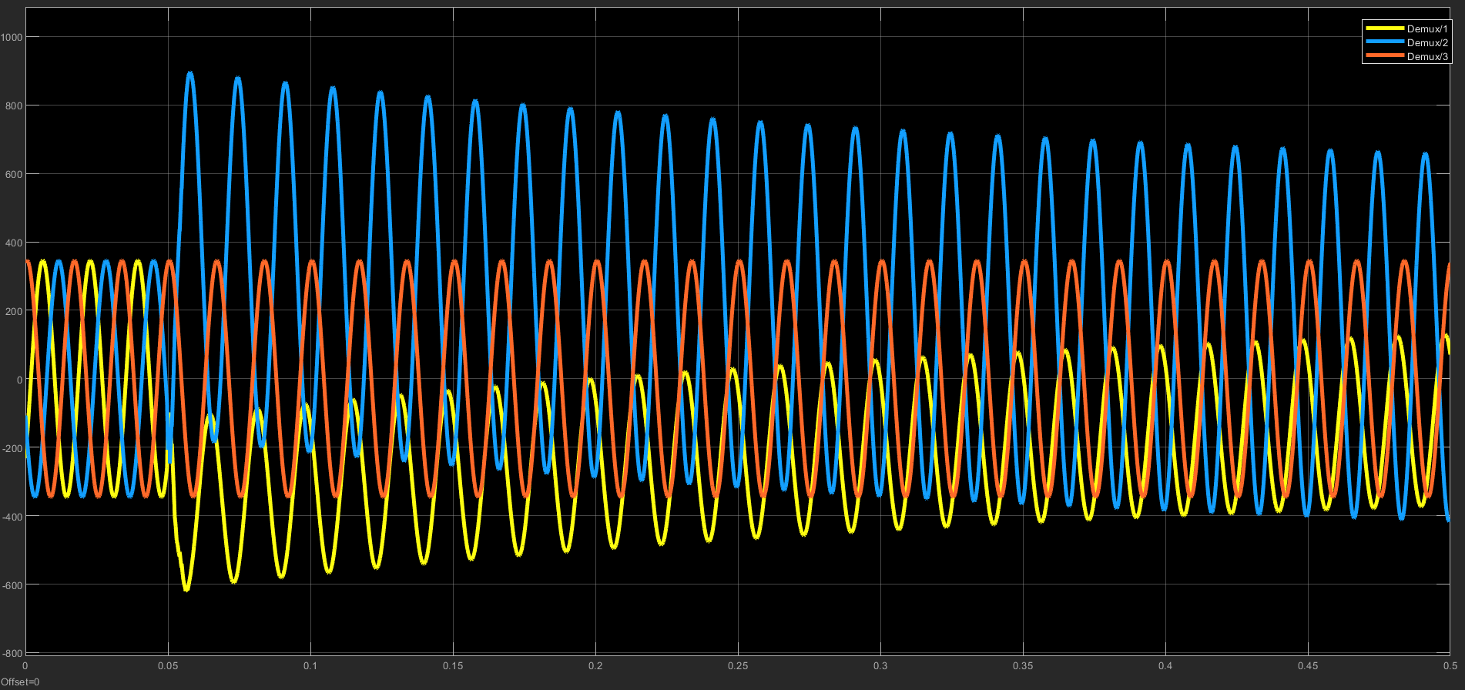
LLLG fault without Overcurrent Relay (generator side)

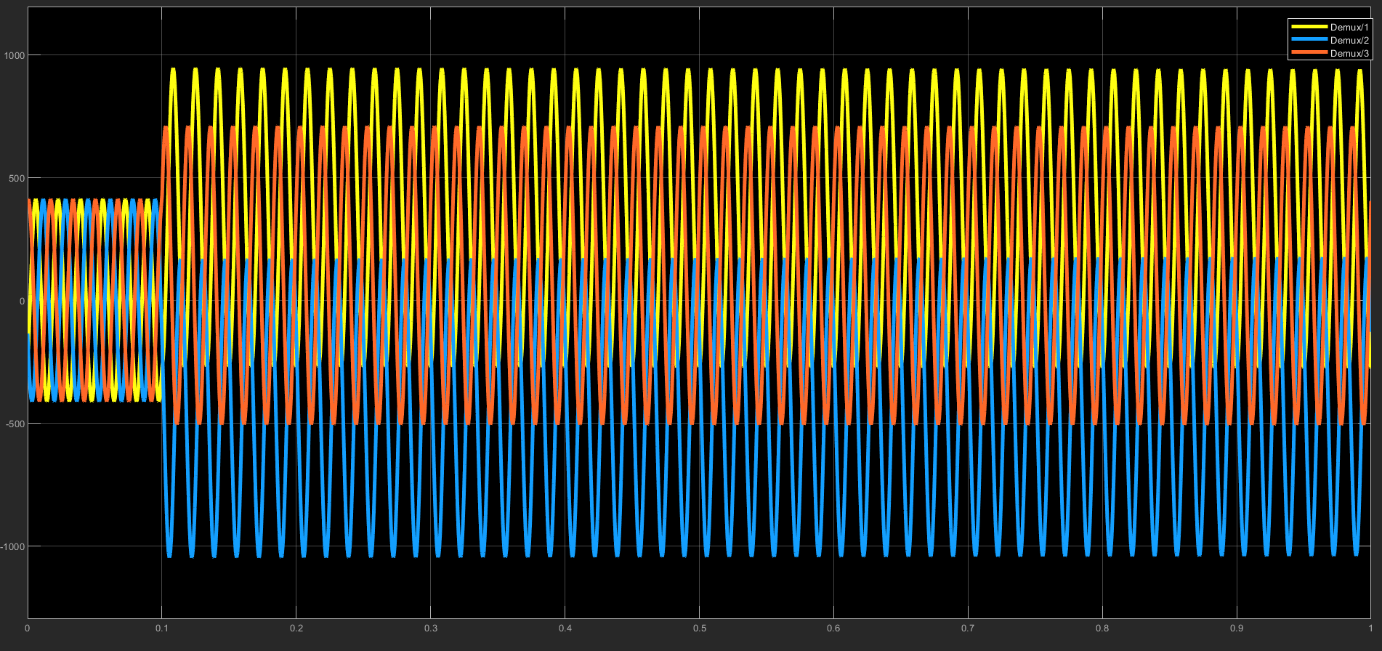

LLLG fault without Overcurrent Relay (Transmission side)

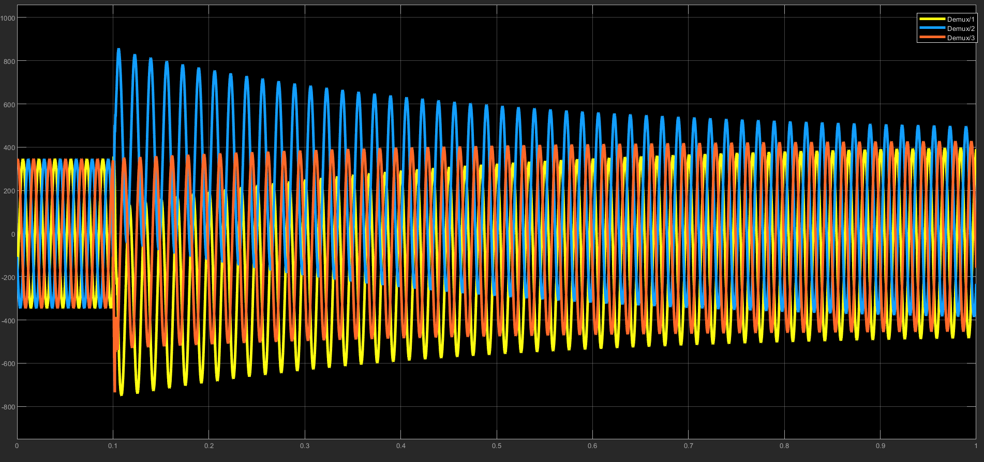

LLLG fault with Overcurrent Relay (Generator side)

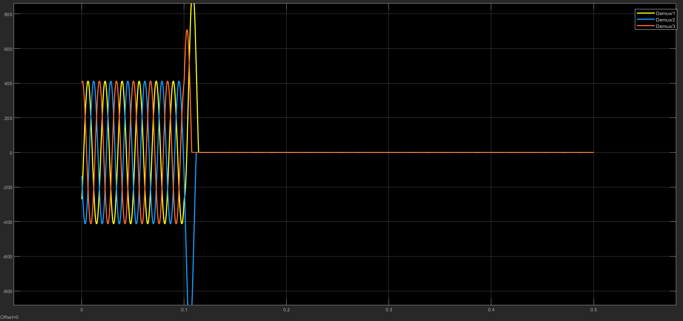
LLLG fault with Overcurrent Relay (Transmission side)

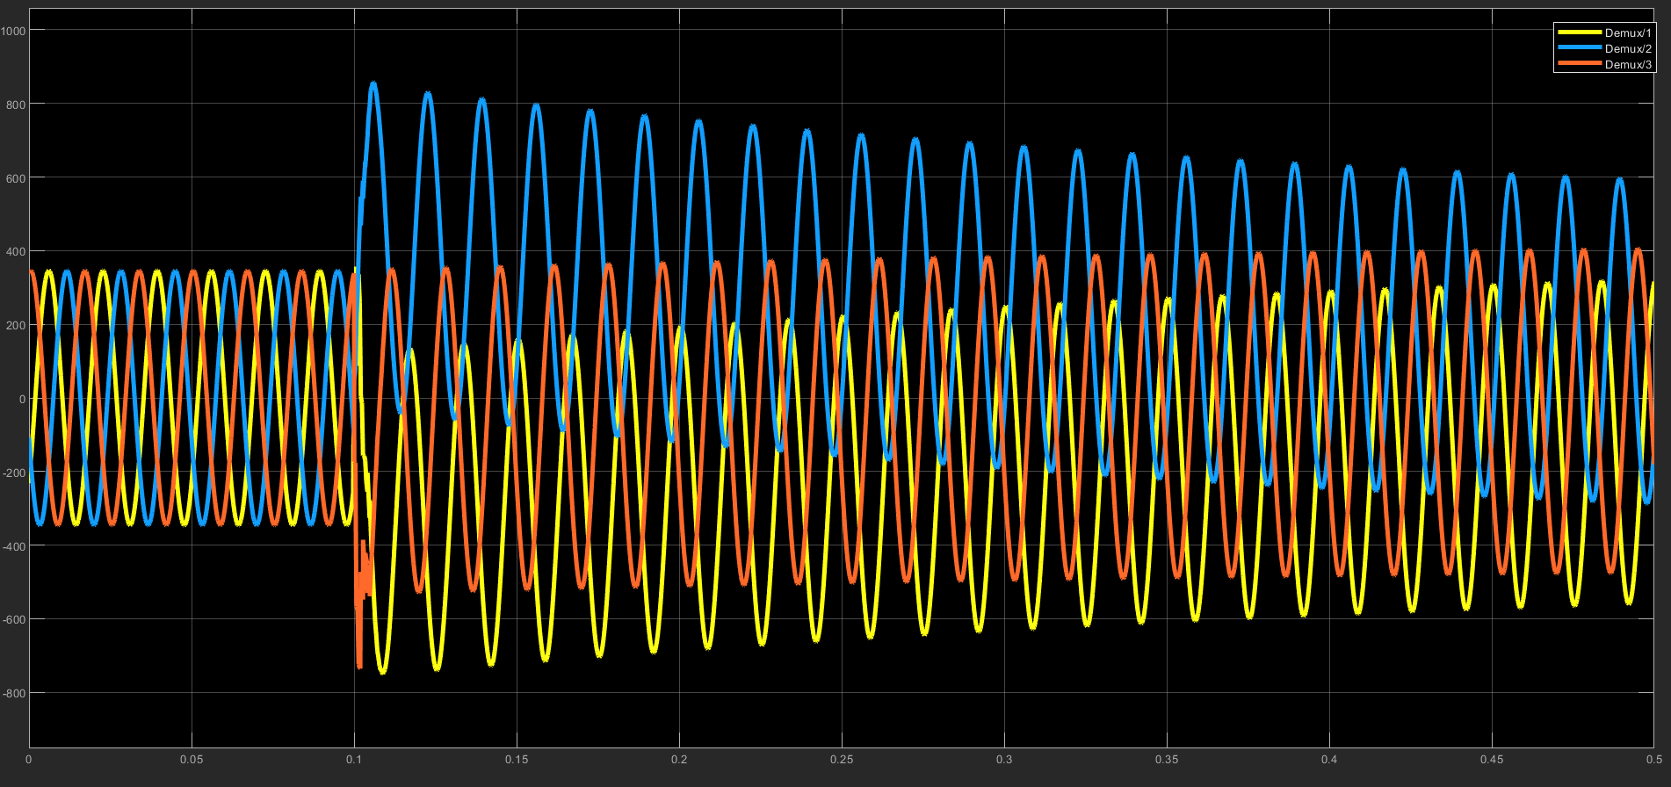

LLG fault with Overcurrent Relay (generator side)

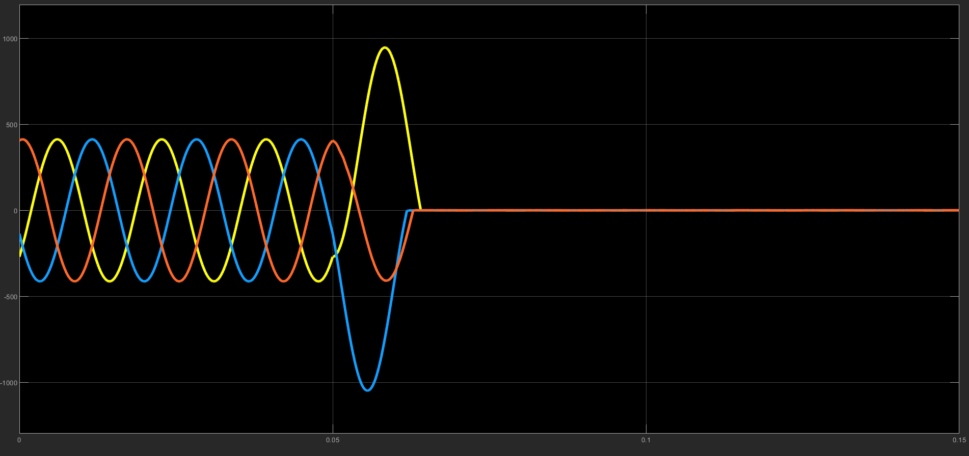

LLG fault with Overcurrent Relay (transmisiion side)

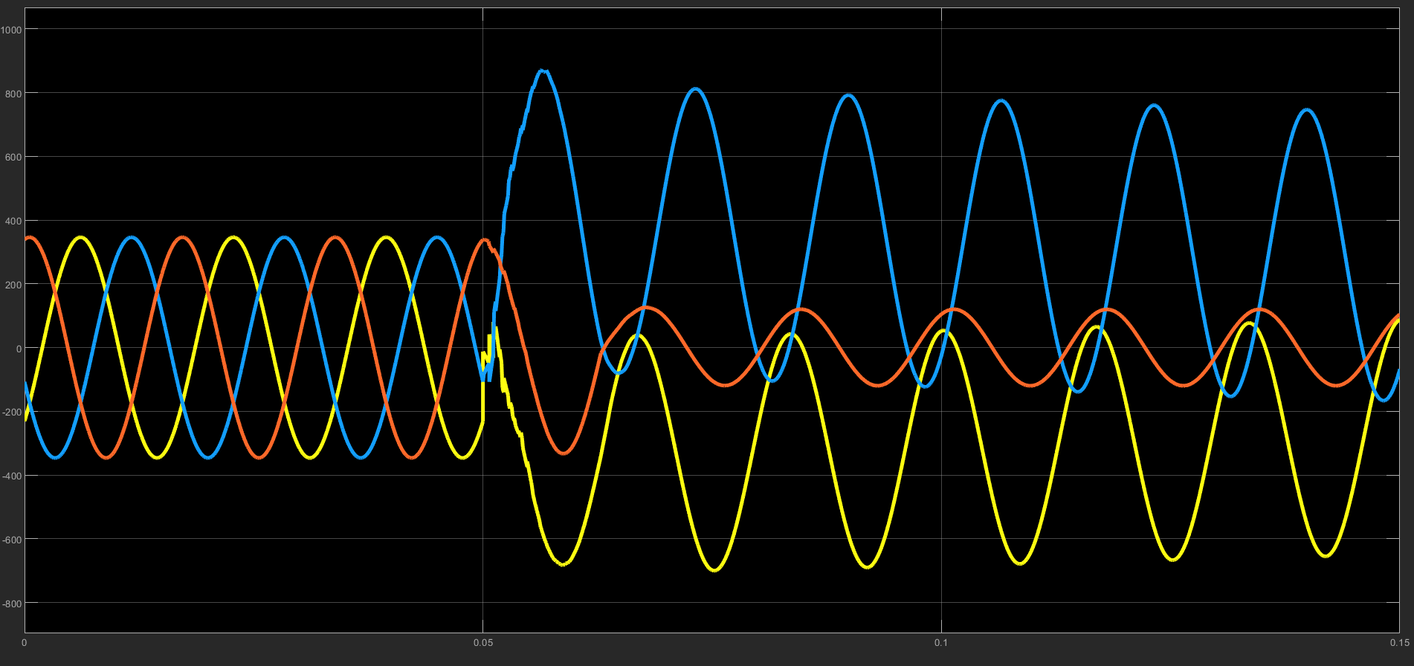
LLG fault without relay (Generator side )

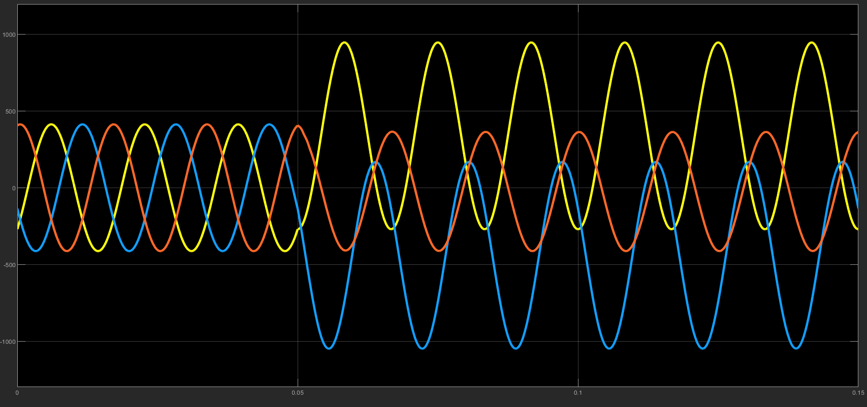

LLG fault Without relay (transmission side )

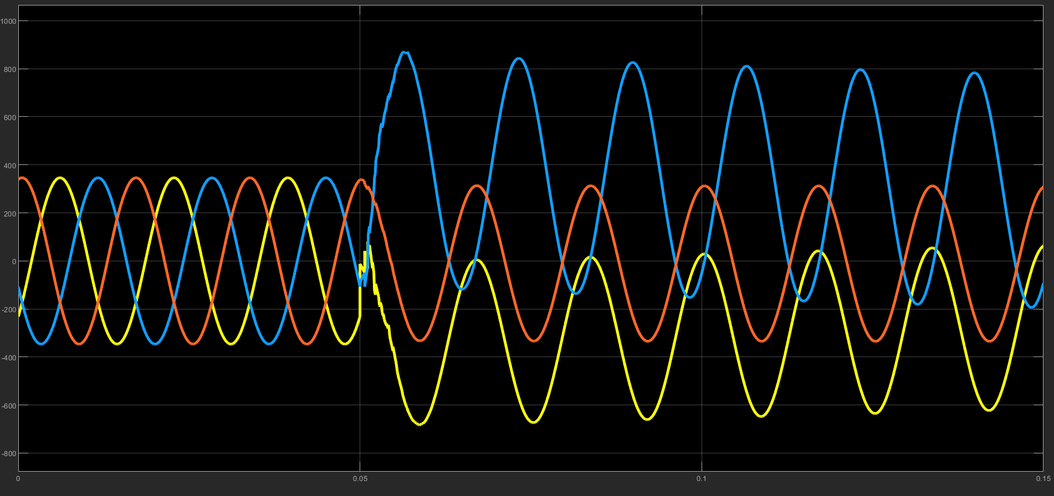

4.6 load flow analysis

Load flow analysis data:

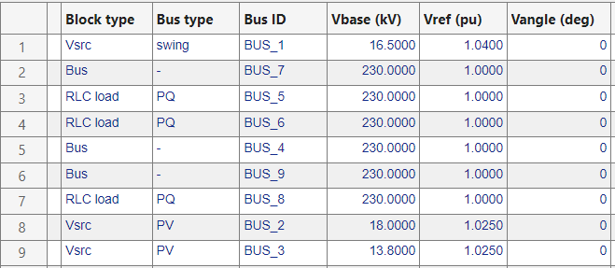

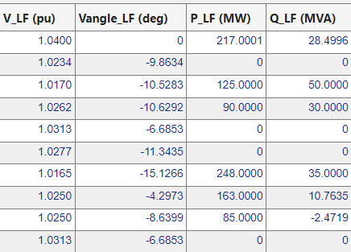
The active power generated from swing bus and two PV buses is 465 W and the power absorbed by the three PQ buses is 463 W.
4.7 Github Link

5 Design Analysis and Evaluation

The project titled "Simulink based programs for power system dynamic analysis using IEEE 9 bus" encompasses the development and application of a Simulink model to analyze the dynamics of power systems. This section delves into the various facets of the project from novelty to ethical considerations.

5.1 Novelty

The novelty of this project lies in its integrated approach towards power system dynamic analysis by employing a Simulink-based IEEE 9 bus system model, supplemented with MATLAB coded models for generators, turbines, and exciters. This integration facilitates a more detailed and nuanced simulation of power system dynamics, offering insights that are closer to real-world phenomena than those provided by traditional analysis methods. The project's uniqueness also stems from its custom-built MATLAB code segments that enable the simulation of specific generator, turbine, and excitor behaviors within the Simulink environment, thus enhancing the model's accuracy and applicability.

5.2 Design Considerations

5.2.1 Considerations to Public Health and Safety

The design of this project meticulously considers the implications on public health and safety by ensuring that the simulations accurately reflect the stability and reliability of power systems. Through dynamic analysis, potential system failures that could lead to outages or hazards are identified and mitigated, thus safeguarding public health and safety.

5.2.2 Considerations of Environment

Environmental considerations are paramount in the design of the project. The simulations aim to optimize the efficiency of power systems, reducing wastage and the need for excessive power generation, which in turn diminishes the environmental footprint of energy production. The project also seeks to model renewable energy sources within the power grid, emphasizing sustainable and eco-friendly energy solutions.

5.2.3 Considerations to Cultural and Societal Needs

This project acknowledges cultural and societal needs by aiming to ensure a reliable power supply, which is a cornerstone of modern society's functionality and development. By enhancing the stability and efficiency of power systems, the project supports societal advancement and contributes to the well-being of communities.

5.3 Investigations

5.3.1 Literature Review

The literature review undertaken for this project highlights the evolution of power system analysis techniques and the increasing relevance of simulation-based approaches. It underscores the gap in dynamic analysis that this project aims to fill by utilizing a Simulink-based model integrated with MATLAB coding for enhanced simulation capabilities.

5.3.2 Experiment Design

The experiment design involves the creation of a Simulink model for the IEEE 9 bus system, integrated with custom MATLAB code for generators, turbines, and exciters. This setup is used to simulate various scenarios including load changes, system faults, and integration of renewable energy sources to evaluate the system's dynamic response and stability.

5.3.3 Data Analysis and Interpretation

Data analysis from the simulations provides critical insights into the system's behavior under different conditions. The interpretation of this data helps in understanding the resilience of the power system, the effectiveness of different configurations, and the impact of renewable integration on system stability.

5.4 Limitations of Tools

While Simulink and MATLAB offer powerful platforms for simulation, they have limitations in terms of scalability and the granularity of some models. These tools may also require simplifications that can impact the accuracy of complex interactions within the power system.

5.5 Impact Assessment

5.5.1 Assessment of Societal and Cultural Issues

The project positively impacts society by promoting the reliability and efficiency of power systems, which are crucial for economic development and quality of life. It respects cultural diversity by recognizing the universal need for sustainable and stable energy.

5.5.2 Assessment of Health and Safety Issues

By focusing on system stability and identifying potential failures, the project directly contributes to the prevention of accidents and hazards associated with power system instabilities, thus safeguarding public health and safety.

5.5.3 Assessment of Legal Issues

The project aligns with legal standards and regulations concerning power system operations and safety. It underscores the importance of adhering to these regulations to ensure the reliability and safety of power supply.
5.6 Sustainability and Environmental Impact Evaluation

The project emphasizes the reduction of environmental impact through efficient power system operation and the integration of renewable energy sources. This approach promotes sustainability by decreasing the reliance on fossil fuels and minimizing ecological footprints.

5.7 Ethical Issues

Ethically, the project commits to the principles of fairness, transparency, and responsibility. It acknowledges the critical role of power systems in society and strives to improve them without compromising ethical standards. The design and analysis processes consider the broader impacts on society, environment, and individual rights, ensuring that the project's outcomes are beneficial and just.

In summary, this project stands at the intersection of advanced simulation techniques and power system dynamics analysis, marked by its novel approach, comprehensive design considerations, and its commitment to societal, environmental, and ethical principles.

6 Reflection on Individual and Teamwork

6.1 Individual Contribution of Each Member
Creating Simulink Model | 2006173, 2006186, 2006187, 2006192, 2006193
Code Preparation | 2006173, 2006186, 2006187 , 2006192, 2006193

6.2 Mode of Teamwork
The modes of teamwork we used are:
Collaborative Teamwork: This was the setting we utilized the most. The majority of our project's work was completed through effective cooperation. We frequently met in our hall room to collaborate on the project. In this manner, we addressed crucial project-related issues, shared our tasks, and exchanged ideas on how to undertake different tasks.
Divided Responsibilities: Team members were given duties to do in this mode. Each group member was given a specific task. Everyone did what they were supposed to do.
Hybrid Approaches: Sometimes collaborative work was necessary; some other times leader-driven teamwork was the only option. Overall, we used different modes of teamwork mixing them up.

6.3 Diversity Statement of Team
Our team is made up of people with various backgrounds, viewpoints, and skills. Diversity is therefore the key to the success of our endeavor. Every team member should feel respected, heard, and empowered in the inclusive and courteous atmosphere that we are dedicated to fostering. In our collaborative efforts, we vow to,
Open Communication: Team members are encouraged to communicate honestly and openly. We think that having a variety of points of view help us make better decisions and produce stronger results.
Learn from Each Other: Diversity offers a priceless chance to learn. We are dedicated to sharing knowledge and working together to advance both personally and professionally.

6.4 Logbook of Project Implementation
Date | Milestone achieved | Individuals involved
January 27, 2024 | Collecting Resources | 2006173, 2006186, 2006187
February 15, 2024 | Creating Basic Simulink Model | 2006173, 2006192
February 16, 2024 | Sketching Matlab Code | 2006186, 2006193
February 20, 2024 | Synchronizing Simulink model and Matlab Code | 2006187, 2006192, 2006193
February 25, 2024 | Bug fixing of Matlab Codes | 2006173,2006186,2006187,2006192,2006193
March 1, 2024 | Report writing and Simulating and Rechecking Code | 2006173,2006186,2006187,2006192,2006193

7 Communication to External Stakeholders

7.1 Executive Summary

[Dhaka, Bangladesh] – [02.03.2024] – Engineers can now analyze the dynamic behavior of power systems with greater precision thanks to a new Simulink-based power system dynamic analysis tool. This innovative project, developed by us; a team from BUET, leverages the power of Simulink's graphical modeling environment to create a user-friendly platform for simulating real-world scenarios.

The tool allows engineers to assess system stability, response to disturbances, and integration of renewable energy sources. This vital information can be used to optimize power system design, improve grid resilience, and ensure reliable electricity delivery.

7.2 User Manual

1. Open the Simulink file in your system computer

2. Change the bus and node parameters according to your system

3. Run the program

4. From the section PowerGui, Select your option to know different characteristics

5. Sync the data according to real-time scenarios

8 Project Management and Cost Analysis

Not Applicable

9 Future Work

1.Integration of Renewable Energy Sources: Enhance the project by incorporating models for renewable energy sources such as solar and wind power generation. This will enable more comprehensive analysis and optimization of hybrid power systems.
2. Real-Time Simulation: Develop capabilities for real-time simulation to facilitate hardware-in-the-loop (HIL) testing and validation of control algorithms. This will be crucial for ensuring the reliability and stability of power systems in practical applications.
3. Advanced Fault Analysis: Extend the project to include advanced fault analysis techniques, such as transient fault analysis and fault location identification. This will help in improving the resilience and reliability of power systems against various fault scenarios.
4. Cybersecurity Analysis: Integrate cybersecurity analysis tools to assess the vulnerability of power system control and communication networks to cyber-attacks. Enhancing the project with cybersecurity features will be essential for ensuring the security and integrity of power system operations.
5. Machine Learning Integration: Explore the integration of machine learning algorithms for predictive maintenance and fault detection in power systems. Leveraging machine learning techniques can enhance the accuracy and efficiency of power system analysis and optimization.
6. Multi-Objective Optimization: Extend the project to support multi-objective optimization techniques for simultaneously optimizing multiple performance metrics, such as system stability, efficiency, and cost. This will enable engineers to find optimal solutions considering various conflicting objectives.
7. Grid Modernization Features: Incorporate features for grid modernization, such as demand response management and distributed energy resource integration. This will support the development of smarter and more flexible power grids capable of accommodating emerging technologies and changing demand patterns.
8. User Interface Enhancements: Improve the user interface of the project to make it more intuitive and user-friendly. Enhancements could include interactive visualization tools, customizable dashboards, and guided workflows to streamline the modeling and analysis process.

10 References

- https://www.sciencedirect.com/science/article/pii/S1018363918307104
- https://github.com/rwl/JDYN
- https://youtube.com/playlist?list=PLq_hRkMmz7XcpKCaEHP50hQAgZgEcbuQq&si=cQ6yfoHAIN57DV6H
- https://youtube.com/playlist?list=PLVtNXzzR8XDp2o8cnXYTsNpHGupJ7J9Cc&si=gNqxTTPVyuBjKWuA
- https://www.google.com/url?sa=t&rct=j&q=&esrc=s&source=web&cd=&cad=rja&uact=8&ved=2ahUKEwiI7_6C_eKEAxVo1jgGHSuqCakQFnoECA8QAQ&url=https%3A%2F%2Fcourses.physics.illinois.edu%2Fece576%2Fsp2018%2FSauer%2520and%2520Pai%2520book%2520-%2520Jan%25202007.pdf&usg=AOvVaw0NdpvY3Qne-yh7Q9vVfea2&opi=89978449
- https://books.google.com.bd/books?id=zM4VatZmj9oC&lpg=PA67&ots=yjOJHpKHMv&dq=power%20system%20dynamics%20using%20matlab%20code&lr&pg=PA67#v=onepage&q&f=false
- https://books.google.com.bd/books?id=9X_PDwAAQBAJ&lpg=PA19&ots=zP6WIXMMtC&dq=power%20system%20dynamics%20using%20matlab%20code&lr&pg=PA1#v=onepage&q&f=false

